FOTO | MODEL | PRET
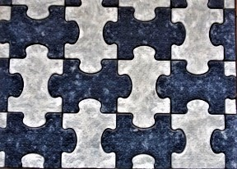 | PAVAJ-PAZLE  Grosime--- 3,8 cm  Lungime – 44.5 cm  Latime-----28.5 cm  Greutate – 85 kg/12 buc/m2  PAVAJ-PAZLE  Grosime--- 2,5 cm  Lungime – 44.5 cm  Latime-----28.5 cm  Greutate – 55 kg/12 buc/m2 | COLOR-  220L/M2  COLOR-  205L/M2
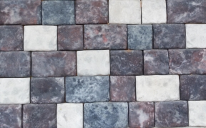 | PAVAJ-STARII GOROD H-3  UN COMPLECT 3 PETRE  Grosime—3 cm  Lungime – 20 cm/15 cm/12 cm  Latime-----12 cm/12 cm/12 cm  Greutate – 60 kg/ 19 compl/m2 | COLOR-  220L/M2
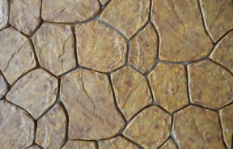 | PAVAJ-CORSICA  UN COMPLECT 6 PETRE-0.382 m2  Grosime--- 4.5 cm  Greutate - -90 kg/ 2.6 compl /m2  PAVAJ-CORSICA  UN COMPLECT 6 PETRE-0.382 m2  Grosime--- 2.5 cm  Greutate - -55 kg/2.6 compl /m2 | COLOR-  240L/M2  COLOR-  210L/M2
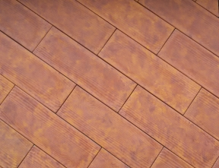 | PAVAJ- DOSCA (PARCHET)  Grosime---3.8 cm  Lungime – 60 cm  Latime-----20 cm  Greutate – 85 kg/8.7 buc/m2  PAVAJ- DOSCA (PARCHET)  Grosime---2.5 cm  Lungime – 60 cm  Latime-----20 cm  Greutate – 55 kg/8.7 buc/m2 | COLOR-  220L/M2  COLOR-  205L/M2
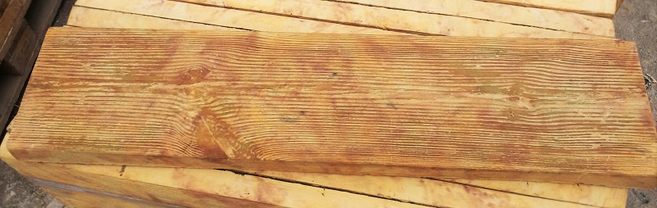 | PAVAJ- DOSCA (PARCHET)  Grosime---4.5 cm  Lungime – 100 cm  Latime------25 cm  Greutate – 90 kg/4 buc/m2 | COLOR-  290L/M2
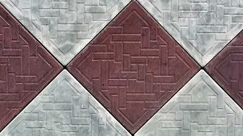 | PAVAJ- SAMARCAND  Grosime---3.5 cm  Lungime – 38.5 cm  Latime-----38.5 cm  Greutate – 80 kg/6.75 buc/ m2  PAVAJ- SAMARCAND  Grosime---2.5 cm  Lungime – 39.5 cm  Latime-----39.5 cm  Greutate – 55 kg/6.75 buc/ m2 | COLOR-  220L/M2  COLOR-  205L/M2
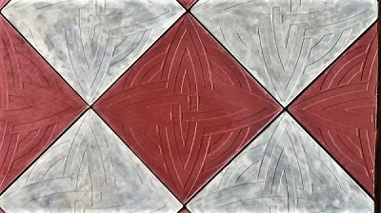 | PAVAJ- ROZA VETROV  Grosime---3.8 cm  Lungime – 39.5 cm  Latime-----39.5 cm  Greutate – 85 kg/6.6 buc/ m2  PAVAJ- SAMARCAND  Grosime---2.5 cm  Lungime – 40 cm  Latime-----40 cm  Greutate – 55 kg/6.6 buc/ m2 | COLOR-  220L/M2  COLOR-  205L/M2
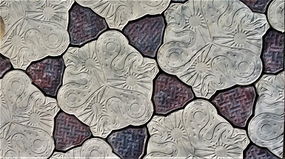 | PAVAJ- TANET ZMEI  UN COMPLECT 1MARE+2MICI  Grosime---3.8 cm  Lungime – 45 cm  Latime-----45 cm  Greutate – 85 kg/5.7 compl /m2  PAVAJ- TANET ZMEI  Grosime---2.5cm  Lungime – 45 cm  Latime-----45 cm  Greutate – 55 kg/5.7 compl /m2 | COLOR-  240L/M2  COLOR-  215L/M2
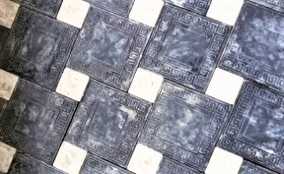 | PAVAJ- GOTICA+CUB  Grosime---4 cm  Lungime – 30.5 cm /CUB 12 cm  Latime-----30.5 cm/CUB 12 cm  Greutate – 85 kg/ 9.3buc/m2  PAVAJ- GOTICA+CUB  Grosime---2.5 cm  Lungime – 30.5 cm/CUB 12 cm  Latime-----30.5 cm/CUB 12 cm  Greutate – 55 kg/9.3 buc/m2 | COLOR- 240L/M2  COLOR-  215L/M2
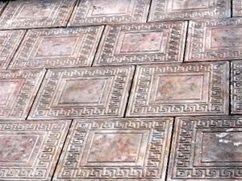 | PAVAJ- GOTICA+CUB  Grosime---4 cm  Lungime – 30.5 cm  Latime-----30.5 cm  Greutate – 85 kg/ 10.75 buc/m2  PAVAJ- GOTICA+CUB  Grosime---2.5 cm  Lungime – 30.5 cm  Latime-----30.5cm  Greutate – 55 kg/10.75 buc/m2 | COLOR- 220L/M2  COLOR-  205L/M2
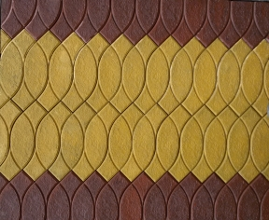 | PAVAJ- VOLNA  Grosime---4 cm  Lungime – 40 cm  Latime-----10 cm  Greutate – 85 kg/25 buc/m2  PAVAJ- VOLNA  Grosime---2.5 cm  Lungime – 40 cm  Latime-----10 cm  Greutate – 55 kg/25 buc/m2 | COLOR-  220L/M2  COLOR-  205L/M2
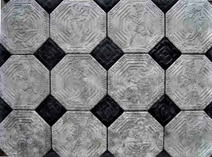 | PAVAJ- GRECIA  UN COMPLECT 1MARE+1MICA  Grosime---4 cm  Lungime – 30 cm  Latime-----30 cm  Greutate – 85 kg/11.5 buc/m2  PAVAJ- GRECIA  Grosime---2.5 cm  Lungime – 30 cm  Latime-----30 cm  Greutate – 55 kg/11.5 buc/m2 | COLOR-  225L/M2  COLOR-  215L/M2
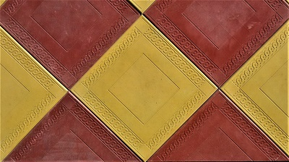 | PAVAJ- ORNAMENT  Grosime---5 cm  Lungime – 40 cm  Latime-----40 cm  Greutate – 105 kg/6.25 buc/m2  PAVAJ- ORNAMENT  Grosime---2.5 cm  Lungime – 40 cm  Latime-----40 cm  Greutate – 55 kg/6.25 buc/m2 | COLOR-  225L/M2  COLOR-  205L/M2
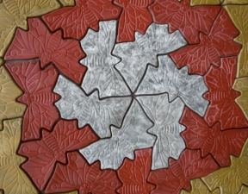 | PAVAJ-FLUTURAS  Grosime---4 cm  Lungime – 40 cm  Latime-----21 cm  Greutate – 85 kg/13 buc/m2  PAVAJ-FLUTURAS  Grosime---2.5 cm  Lungime – 40 cm  Latime-----21 cm  Greutate – 55 kg/13 buc/m2 | COLOR-  200L/M2  COLOR-  180L/M2
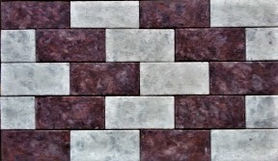 | PAVAJ-CHIRPICEC  Grosime---3 cm  Lungime – 23.5 cm  Latime-----11.5 cm  Greutate – 81 kg/37 buc/m2  PAVAJ- CHIRPICEC  Grosime---2 cm  Lungime – 23.5 cm  Latime-----11.5 cm  Greutate – 50 kg/37buc/m2 | COLOR-  220L/M2  COLOR-  200L/M2
 | PAVAJ-DOSCA K  Grosime---3 cm  Lungime – 30 cm  Latime-----30 cm  Greutate – 85 kg/11 buc/m2  PAVAJ-DOSCA K  Grosime---2 cm  Lungime – 30 cm  Latime-----30 cm  Greutate – 50 kg/11 buc/m2 | COLOR-  210L/M2  COLOR-  200L/M2
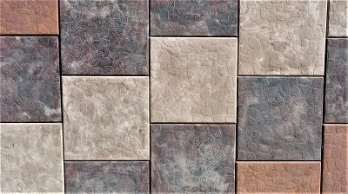 | PAVAJ-GALICA K  Grosime---2.5 cm  Lungime – 25 cm  Latime-----25 cm  Greutate – 50 kg/16 buc/m2 | COLOR-  205L/M2
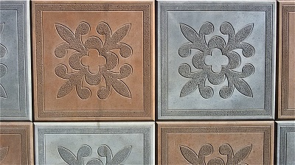 | PAVAJ-FLOARE K  Grosime---3 cm  Lungime – 30 cm  Latime-----30 cm  Greutate – 50 kg/16 buc/m2 | COLOR-  210L/M2  SUR-  190L/M2
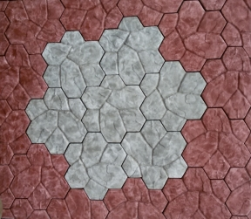 | PAVAJ-ROZA  Grosime---3.5 cm  Lungime –-28 cm  Latime-----28 cm  Greutate – 85 kg/12.5 buc/m2 | COLOR-  200L/M2
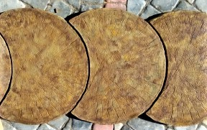 | ELEMENT -TRUNCHI  Ф-60см  Grosime---5 cm  Lungime – 60 cm  Latime-----38 cm  Greutate – 21 kg/ buc | COLOR-  70L/BUC
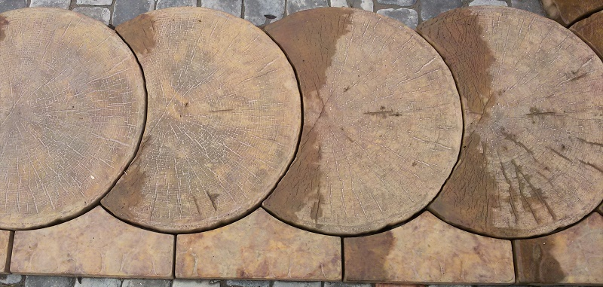 | ELEMENT LATERAL PENTRU  PAVAJ-TRUNCHI Ф-60см  Grosime---5 cm  Lungime – 38 cm  Latime-----10 cm  Greutate – 5 kg/ buc | COLOR-  10L/BUC
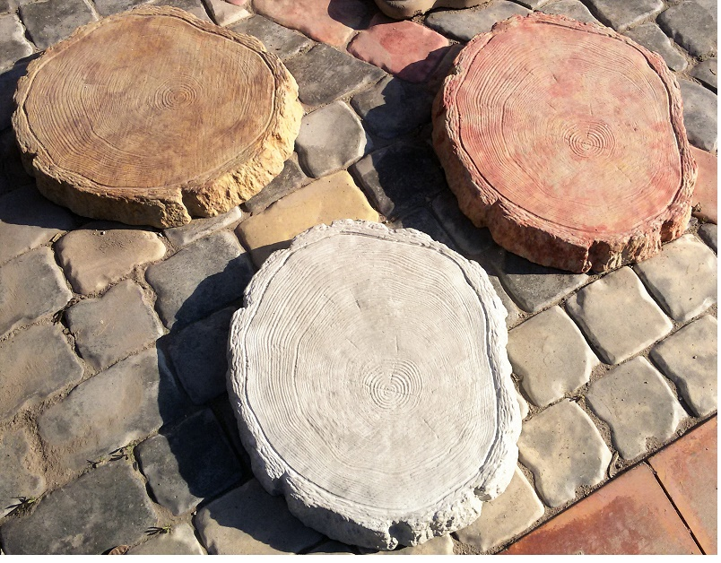 | ELEMENT -BUTUC  Ф-60 см  Grosime---5 cm  Lungime – 43 cm  Latime-----38 cm  Greutate – 16 kg/ buc | COLOR-  70L/BUC
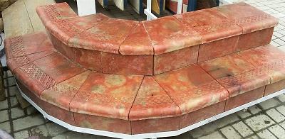 | ELEMENT- TREAPTA COMPLECT  O TREAPTA+O PLACA LATERALA  TREAPTA  Grosime---3.3 cm  Lungime – 34.5 cm  Latime-----28.5 cm  Greutate – 10 kg/compl  LATERALA  Grosime---2.5 cm  Lungime – 28.5 cm  Latime-----15 cm  Greutate – 3 kg/compl | COLOR-  60L/COMPL  50L/TREAPTA  GRI-  48L/ COMPL
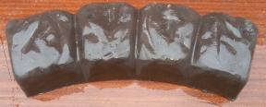 | BORDUR №1  SEMIROTUND- BULIJNIC-4 PETRE  CERC LA COPAC  Un complect 8 buc  INTERIOR ф-100 cm  EXTERIOR ф—90 cm  Innaltime—7 cm  Lungime – 46 cm  Latime-----13 cm  Greutate – 8 kg/ buc | COLOR-  40L/BUC  GRI-  35L/BUC
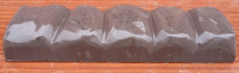 | BORDUR №2  BULIJNIC  Innaltime—7 cm  Lungime – 50 cm  Latime-----13 cm  Greutate – 9 kg/ buc | COLOR-  65L/BUC  GRI-  55L/BUC
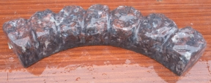 | BORDUR №3  SEMIROTUND 8 PETRE  CERC LA COPAC  Un complect 4 buc  INTERIOR ф-66 cm  EXTERIOR ф-90 cm  Innaltime—7 cm  Lungime – 69 cm  Latime-----13 cm  Greutate -12 kg/buc | COLOR-  65L/BUC  GRI-  55L/BUC
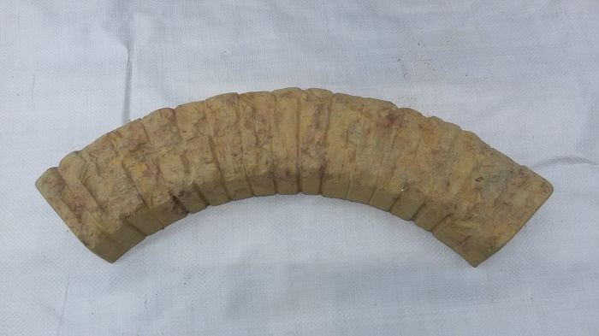 | BORDUR №4  SEMIROTUND LAPSA  CERC LA COPAC  Un complect 4 buc  INTERIOR ф-62 cm  EXTERIOR ф-86 cm  Innaltime—7 cm  Lungime – 66 cm  Latime-----13 cm  Greutate – 10 kg/buc | COLOR-  65L/BUC  GRI-  55L/BUC
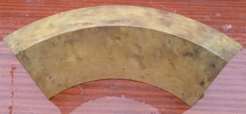 | BORDUR №5 SEMIROTUND  CERC LA COPAC  Un complect 4 buc  INTERIOR ф-45 cm  EXTERIOR ф-5 8 cm  Innaltime—20 cm  Lungime – 45 cm  Latime-----6 cm  Greutate – 12 kg/buc | COLOR-  65L/BUC  GRI-  55L/BUC
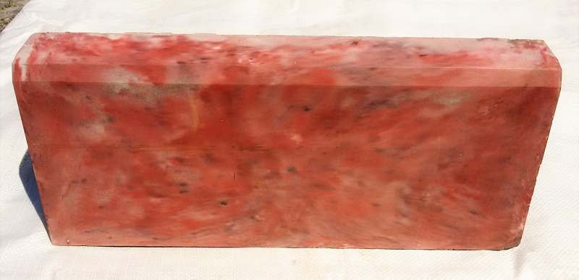 | BORDUR №6  Innaltime—20 cm  Lungime – 50 cm  Latime-----6.5 cm  Greutate – 15 kg/buc  BORDUR №7  Innaltime—20 cm  Lungime – 100 cm  Latime-----7 cm  Greutate – 36 kg/buc | COLOR-  70L/BUC  GRI-  60L/BUC  COLOR-  140L/BUC  GRI-  130L/BUC
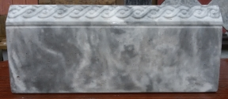 | BORDUR №8  COSICICA  Innaltime—20 cm  Lungime – 50 cm  Latime-----5 cm  Greutate – 10 kg/buc | COLOR-  55L/BUC  GRI-  50L/BUC
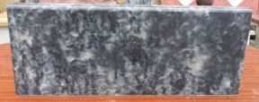 | BORDUR №9  SIMPLU  Innaltime—20 cm  Lungime – 50 cm  Latime-----4 cm  Greutate – 8.2 kg/buc | COLOR-  45L/BUC  GRI-  40L/BUC
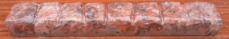 | BORDUR №10 ECO  Innaltime—5 cm  Lungime – 47 cm  Latime-----5 cm  Greutate – 3.5 kg/buc | COLOR-  30L/BUC
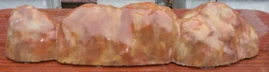 | BORDUR №11  GREDA  Innaltime—12 cm  Lungime –- 55 cm  Latime-----13 cm  Greutate - 12 kg/buc | COLOR-  60L/BUC
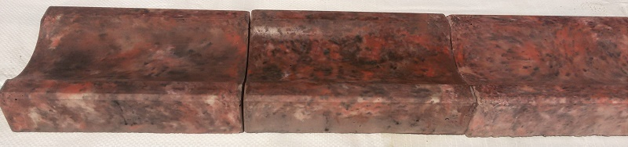 | ULUC №1  Innaltime—6 cm  Lungime –- 25 cm  Latime-----16 cm  Greutate - 4.3 kg/buc | COLOR-  30L/BUC  GRI-  25/BUC
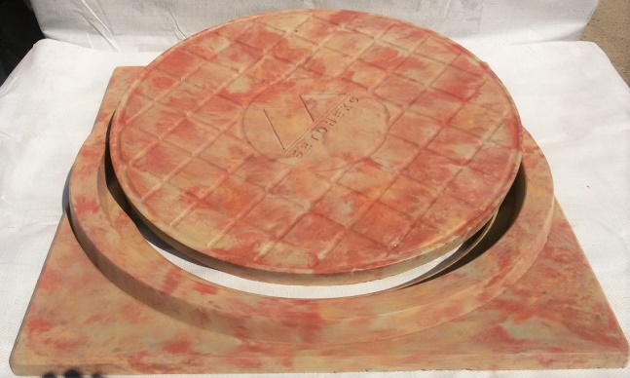 | TRAPA CANALIZARE  Greutate - 68 kg/compl  TALPA-72*78 cm  Greutate - 34 kg/buc  CAPAC  Diametru-68 cm  Greutate – 34 kg/buc | COLOR-600L  GRI-550L/COMPL  400L/TALPA  200L/CAPAC
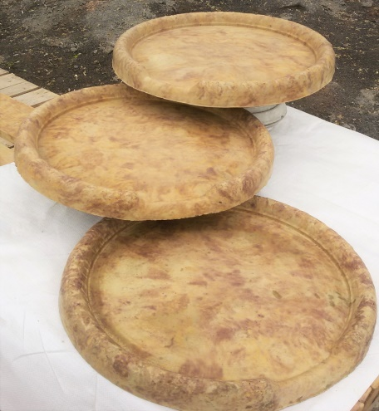 | CASCADA  Diametru—60 cm  Innaltime —8 cm  Greutate - 25 kg/buc | COLOR  200L/BUC
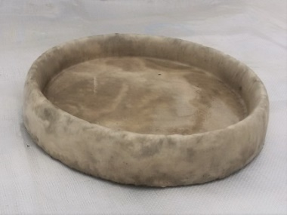 | BOL № 1  PENTRU APA  Diametru—40 cm  Innaltime —7 cm  Greutate - 12 kg/buc | COLOR  120L/BUC
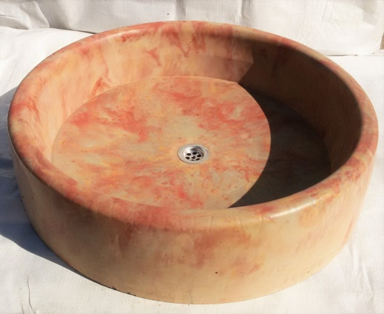 | BOL № 2  PENTRU APA  Diametru—70 cm  Innaltime —18 cm  Greutate - 67 kg/buc | COLOR  600L/BUC
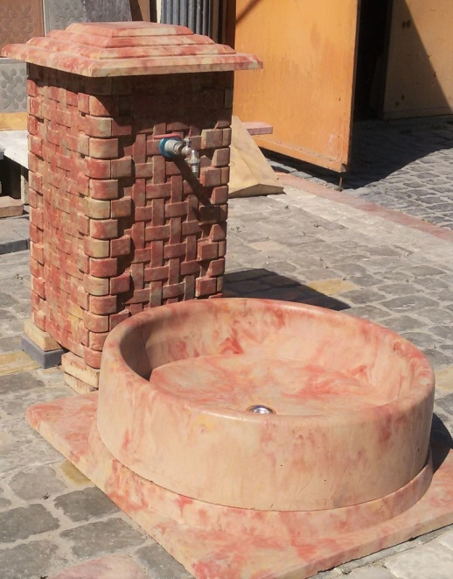 | COMPLECT ROBINET  COAMA STILP 45*45 WIN  GHIVECI Innaltime—70 cm  BOL PENTRU APA Diametru—70 cm  TALPA-72*78 cm  Greutate - 170 kg/buc | COLOR  1560 L/COMPL  160L/BUC*  400L/BUC  600L/BUC  400L/TALPA
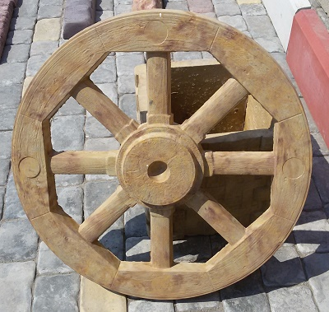 | ROATA  Diametru—70 cm  Grosime—6 cm  Greutate - 20 kg/buc | 300L/BUC
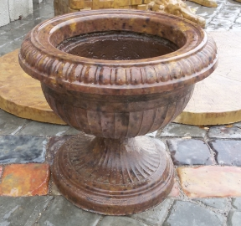 | GHIVECI №1 Ф-26см  Innaltime—38 cm  Greutate - 20 kg/buc  GHIVECI №2 Ф-20см  Innaltime—34 cm  Greutate - 16 kg/buc | 400L/BUC  300L/BUC
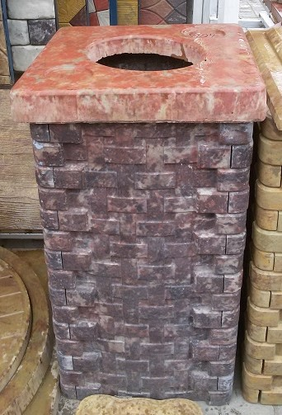 | CAPAC-URNA  CAPAC-URNA №1 COMPLECT  Innaltime—35 cm  Lungime –-38 cm  Latime-----38 cm  Greutate - 20 kg/buc  CAPAC-URNA №2 COMPLECT  Innaltime—70 cm  Lungime –-38 cm  Latime-----38 cm  Greutate - 40 kg/buc | 80L/BUC  300L/BUC  450L/BUC
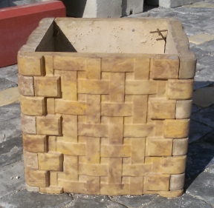 | GHIVECI №3  Innaltime—35 cm  Lungime –-38 cm  Latime-----38 cm  Greutate - 32 kg/buc  GHIVECI №4  Innaltime—70 cm  Lungime –-38 cm  Latime-----38 cm  Greutate - 64 kg/buc | 220L/BUC  370L/BUC
 | GHIVECI №5  Innaltime—36 cm  Lungime –-52 cm  Latime-----52 cm  Greutate - 43 kg/buc | 240L/BUC
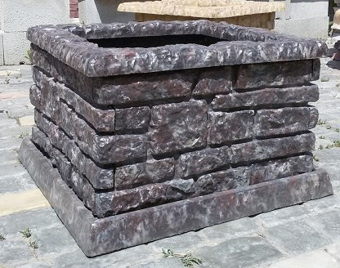 | GHIVECI №6  Innaltime—40 cm  Lungime –-66 cm  Latime-----66 cm  Greutate – 52 kg/buc | 400L/BUC
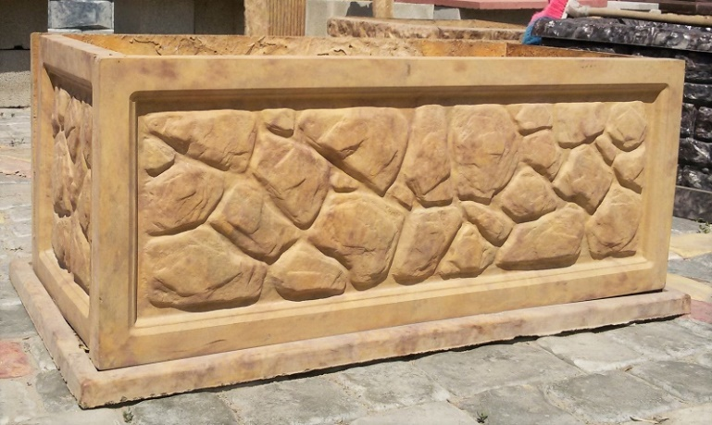 | GHIVECI №7  Innaltime—40 cm  Lungime –-95 cm  Latime-----47 cm  Greutate – 55 kg/buc | 450L/BUC
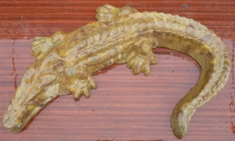 | FIGURA CROCODIL  Innaltime—9 cm  Lungime –-110 cm  Latime-----25 cm  Greutate - 44 kg/buc | 400L/BUC
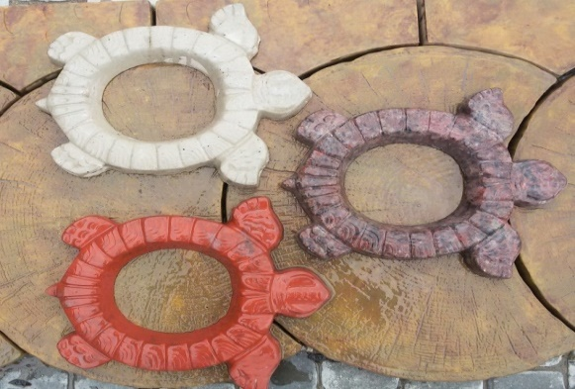 | BROSCUTA TISTOASA  Innaltime—4 cm  Lungime –- 39 cm  Latime-----33 cm  Greutate - 5 kg/buc | COLOR-  40L/BUC
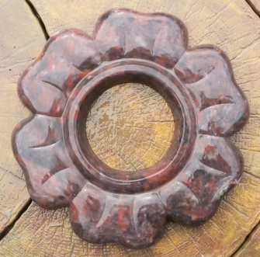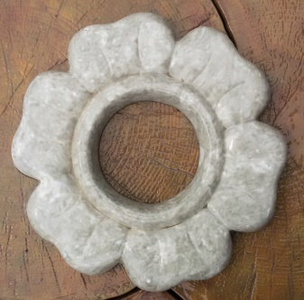 | ROMANITA  Innaltime—4 cm  Diametru—37 cm  Greutate - 7.5 kg/buc | COLOR-  45L/BUC
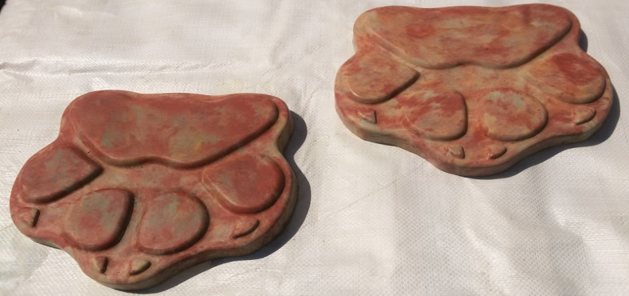 | URMA №1 CIINE  Innaltime—3 cm  Lungime –-30 cm  Latime-----30 cm  Greutate – 6 kg/buc | 50L/BUC
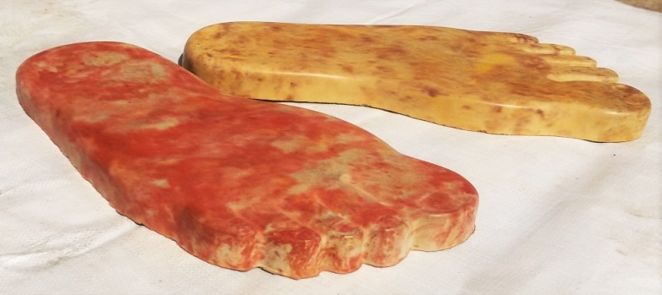 | URMA №2 TALPI  Innaltime—3 cm  Lungime –-54 cm  Latime-----20 cm  Greutate – 11.5 kg/buc | 60L/BUC
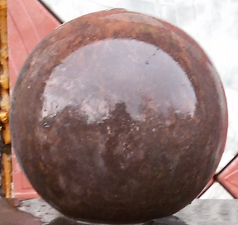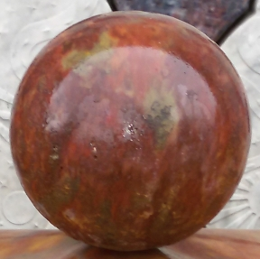 | SFERA DECORATIVA  Ф-150  Ф-200  Ф-250 | 180L/BUC  300L/BUC  350L/BUC
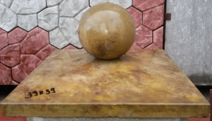 | CAPAC PENTRU STILPI  30x30*8 cm  39x39*8 cm  49x49*6.5 cm  *PRETUL INDICAT E FARA SFERA | 60L/BUC*  80L/BUC*  115L/BUC*
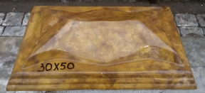 | CAPAC PENTRU STILP  30*50*12cm Cod-MD ---  -------------------- 20 kg/buc | 140L/BUC
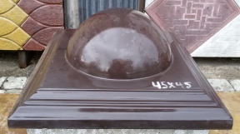 | CAPAC PENTRU STILP  45*45*18cm Cod-VIN---  -------------------34 kg/buc | 170L/BUC*
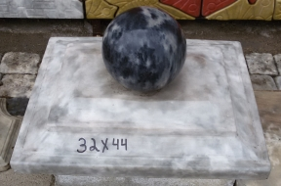 | CAPAC PENTRU STILP  32*44*8 cm Cod-OD---  ------------------18 kg/buc  *PRETUL INDICAT E FARA SFERA | 140L/BUC*
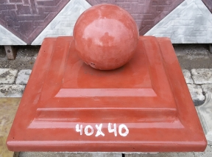 | CAPAC PENTRU STILP  32*32*8cm Cod- OD----  ------------------10 kg/bu  40*40*8cm Cod- OD----  ------------------17 kg/buc  *PRETUL INDICAT E FARA SFERA | 125 L/BUC*  140L/BUC*
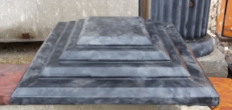 | CAPAC STILP Cod-VIN  30.5*30.5*6 cm -7 kg/buc  31.5*31.5*6 cm -9 kg/buc  36*36*6 cm - ---12 kg/buc  40*40*8.5cm ---18 kg/buc -  45*45*8,8 cm---25 kg/buc  50*50*11 cm----38 kg/buc | 120L/BUC*  125L/BUC*  140L/BUC*  150L/BUC*  160L/BUC*  190L/BUC*
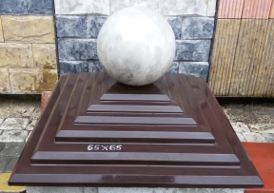 | CAPAC STILP Cod-VIN  50*50*11cm-----38 kg/buc  56*56*11.5cm--46 kg/buc  60*60*13.5cm -70 kg/buc  65*65*14cm----71 kg/buc  *PRETUL INDICAT E FARA SFERA | 190L/BUC*  210L/BUC*  230L/BUC*  260L/BUC*
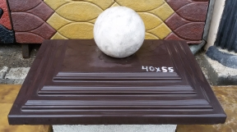 | CAPAC STILP Cod-VIN  36*50*7cm---19 kg/buc  40*55*9 cm --29 kg/buc  50*65*13cm -58 kg/buc  44*66*7.5cm-50 kg/buc  *PRETUL INDICAT E FARA SFERA | 180L/BUC*  200L/BUC*  250L/BUC*  230L/BUC*
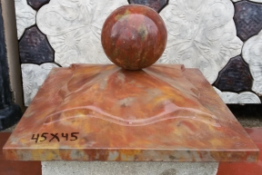 | CAPAC PENTRU STILP  Cod-MD  45*45*10 cm --25 kg/buc  50*50*12 cm -35 kg/buc  55*55*13 cm -40 kg/buc  *PRETUL INDICAT E FARA SFERA | 100L/BUC*  160L/BUC*  180L/BUC*
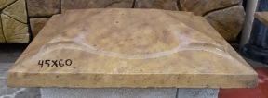 | CAPAC PENTRU STILP  Cod-MD  45*60*13cm--35 kg/buc | 160L/BUC*
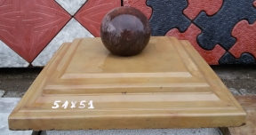 | CAPAC PENTRU STILP  Cod-OD  51*51* 8cm-35 kg/buc  50*50* 8cm-32 kg/buc  *PRETUL INDICAT E FARA SFERA | 160L/BUC*  160L/BUC*
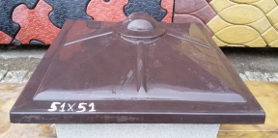 | CAPAC PENTRU STILP  Cod-VIN  51*51*14cm-28 kg/buc | 160L/BUC
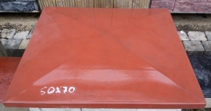 | CAPAC PENTRU STILP  Cod-OD  60*70*13cm-40 kg/buc  70*98*14cm-48 kg/buc | 250L/BUC  300L/BUC
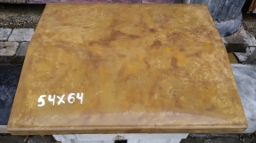 | COAMA PENTRU GARD  50*18*4.5cm ----8 kg/buc  39*27*5.5cm ----10kg/buc  39*35*6cm ------15 kg/buc  50*30*7cm-------17kg/buc  45*40*5cm-------18kg/buc  45*45*5.5cm----21 kg/buc  54*65*6cm-------39kg/buc | 50L/BUC  60L/BUC  75L/BUC  80L/BUC  95L/BUC  110L/BUC  145L/BUC
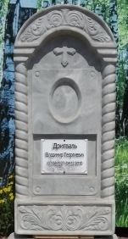 | MONUMENT №1  KOSICICA | 1600L/  complect
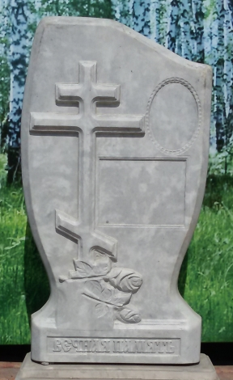 | MONUMENT №2  ROZA | 1400L/  complect
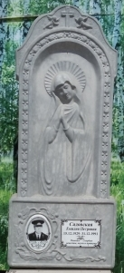 | MONUMENT №3 ROZA  MAICA DOMNULUI | 1800L/  complect
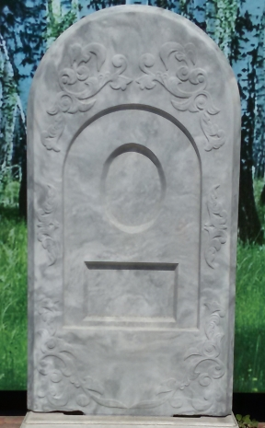 | MONUMENT №4  SIMPLU | 1400L/  complect
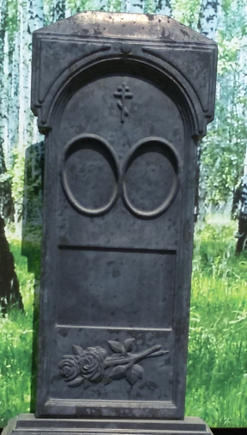 | MONUMENT №5  2 FOTO | 1500L/  complect
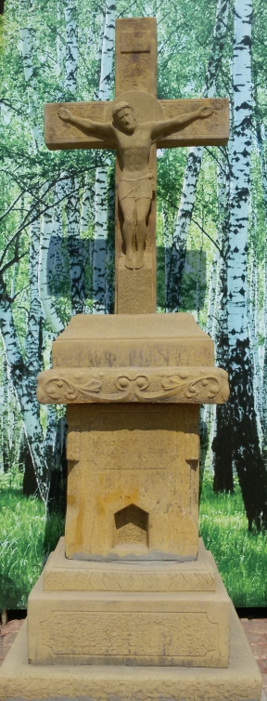 | RASTIGNIRE | 5500L/  complect

NOTA INFORMATIVA
Schimbul si retur de mărfuri nu se acceptă. Prin urmare, Vă rugăm insistent concretizati toate detaliile, pentru a evita probleme ulterioare.
Culoarea produselor poate suferi în funcţie de factorii de mediu: ultaviolet, precipitațiile acide, ect. .

