FOTO | DENUMIRE | PRET
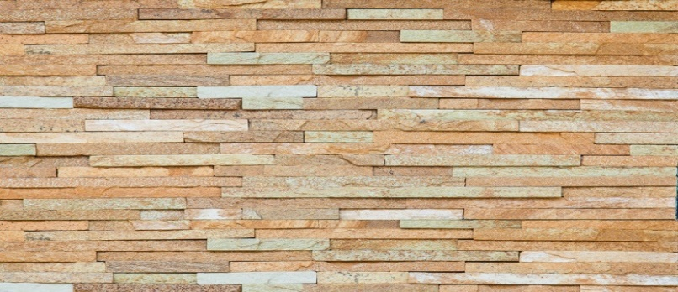 | RUSIA--ZLATOLIT  LAPSA N-1,5  H-1.5(cm)  Lungime - libera  Grosime –0 .7-1.2cm  Greutate - 10-18kg/m2 | 700LEI
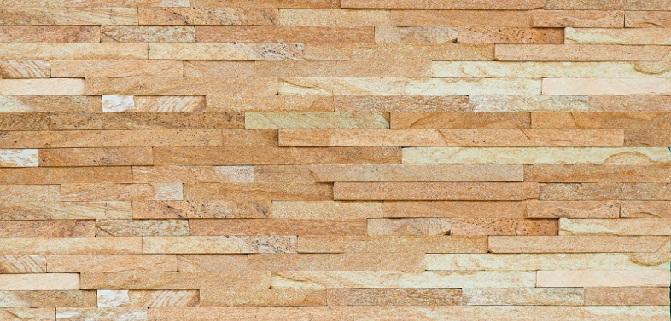 | RUSI---ZLATOLIT  LAPSA N-2,5  H-2.5(cm)  Lungime - libera  Grosime –0 .7-1.2cm  Greutate - 10-18kg/m2 | 700LEI
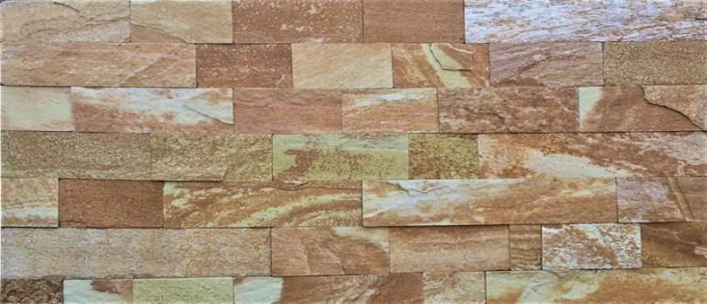 | RUSIA--ZLATOLIT  LAPSA N-5  H- 5(cm)  Lungime - libera  Grosime –0 .7-1.2cm  Greutate - 10-18kg/m2 | 700LEI
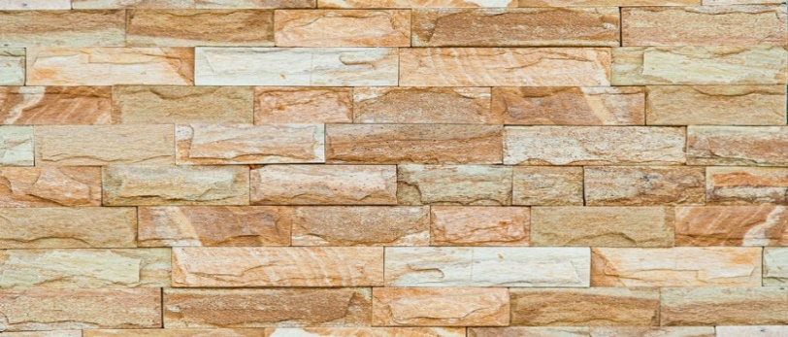 | RUSIA--ZLATOLIT  SKOL N-5  H-5(cm)  Lungime - libera  Grosime –0 .7-1.5cm  Greutate - 10-18kg/m2 | 700LEI
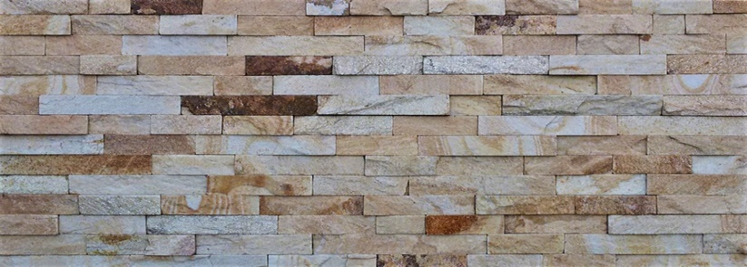 | BULGARIA---BELII PERSIC  LAPSA N-2,5  H-2.5 (cm)  Lungime - libera  Grosime –0 .7-1.2cm  Greutate - 10-18kg/m2 | 490LEI/M2
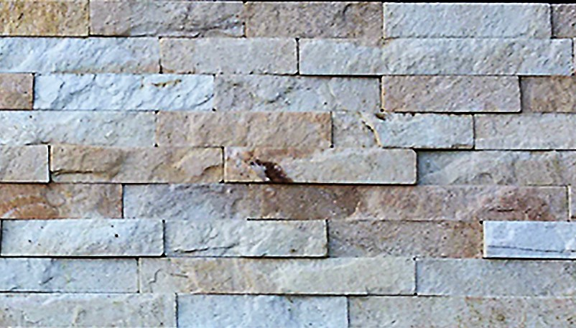 | BULGARIA----BELII PERSIC  LAPSA N-5  LAPSA N-10  H-5 (cm)  H-10 (cm)  Lungime - libera  Grosime –0 .7-1.2cm  Greutate - 10-18kg/m2 | 540LEI/M2  540LEI/M2
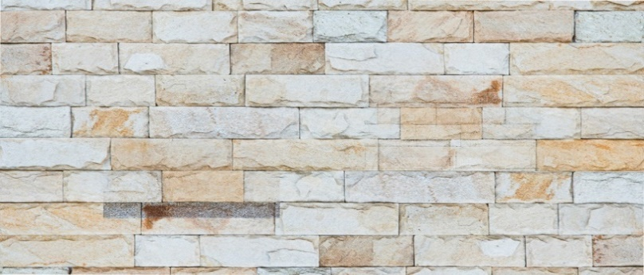 | BULGARIA---BELII PERSIC  SKOL N-5  H-5 (cm)  Lungime - libera  Grosime –1-1.5 cm  Greutate - 15-22 kg/m2 | 590LEI/M2
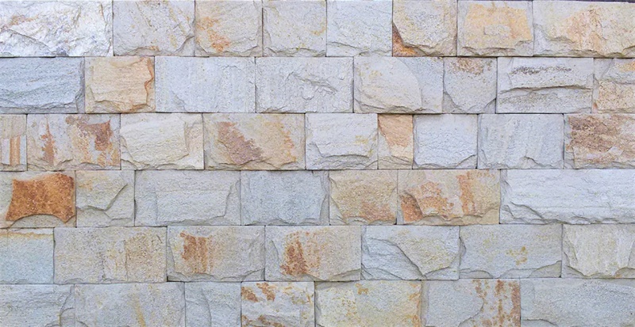 | BULGARIA---BELII PERSIC  SKOL N-10  H-10 (cm)  Lungime - libera  Grosime –0 .7-1.5cm  Greutate - 10-18kg/m2 | 590LEI/M2
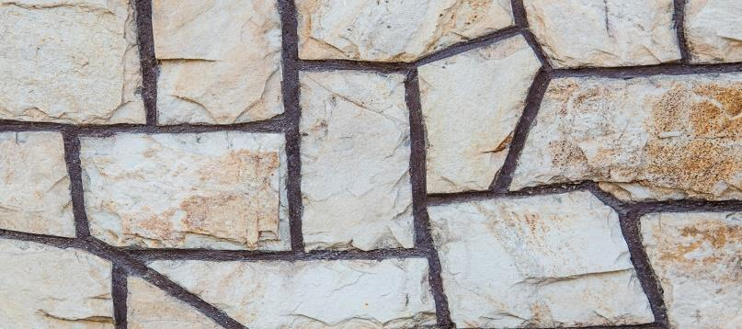 | BULGARIA-----BELII PERSIC  PIATRA MĂRUNTĂ LESPEDE  25-40 PIETRE IN M2  Latime - libera  Lungime - libera  Grosime –2-2.5 cm  Greutate – 35-40 kg/m2  ***MĂSURI APROXIMATIVE | 230 LEI/M2  170 LEI/M2---  la раlet  27 de rinduri  pe palet  4250 LEI/PALET  ( la раlet)****
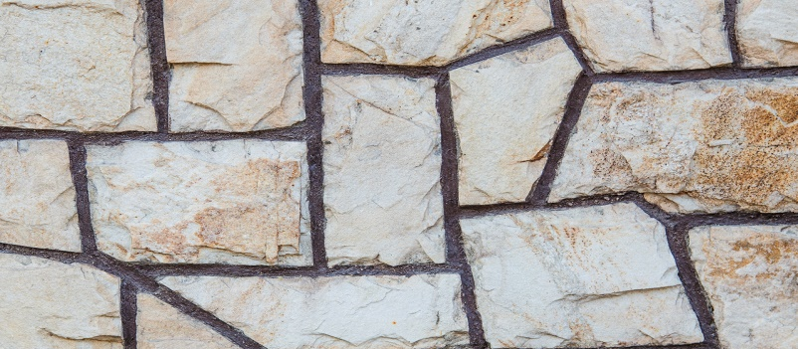 | BULGARIA- -BELII PERSIC  PIATRĂ MĂȘCATA LESPEDE  20-25 PIETRE IN M2  Latime - libera  Lungime - libera  Grosime –2-2.5 cm  Greutate – 35-40 kg/m2  ***MĂSURI APROXIMATIVE | 280LEI/M2—  216 LEI/M2---  27 de rinduri  pe palet  5400 LEI/PALET  ( la раlet)****
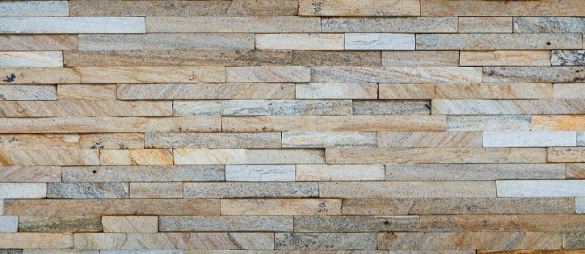 | BULGARIA -DEREVO  LAPSA N-2,5  H-2.5(cm)  Lungime - libera  Grosime –0 .7-1.2cm  Greutate - 10-18kg/m2 | 490LEI/M2
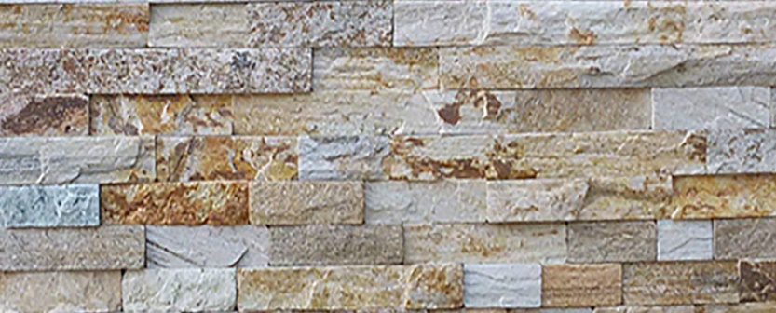 | BULGARIA-----DEREVO  LAPSA N-5  LAPSA N-10  H-5 (cm)  H-10 (cm)  Lungime - libera  Grosime –0 .7-1.2cm  Greutate - 10-18kg/m2 | 540LEI/M2  540LEI/M2
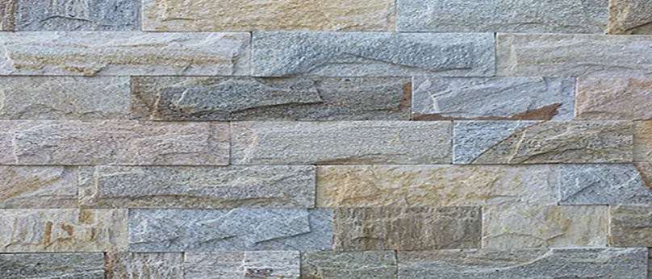 | BULGARIA- DEREVO  SKOL N-5  H-5 (cm)  Lungime - libera  Grosime –1-1.5 cm  Greutate - 15-22 kg/m2 | 590LEI/M2
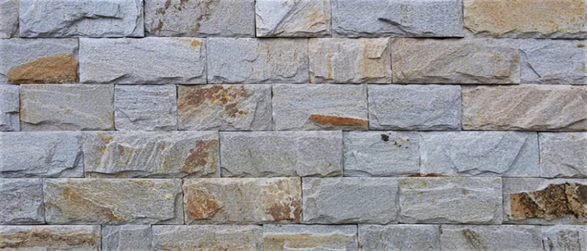 | BULGARIA- DEREVO  SKOL N-10  H-10 (cm)  Lungime - libera  Grosime –1-1.5 cm  Greutate - 15-22 kg/m2 | 590LEI/M2
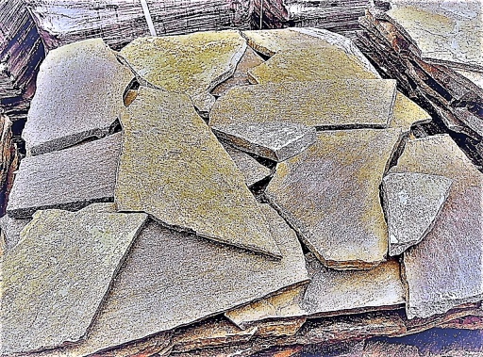 | BULGARIA--- DEREVO  PIATRA MĂRUNTĂ LESPEDE  25-40 PIETRE IN M2  Latime - libera  Lungime - libera  Grosime –2-2.5 cm  Greutate – 35-40 kg/m2  ***MĂSURI APROXIMATIVE | 230 LEI/M2  170 LEI/M2---  la раlet  27 de rinduri  pe palet  4250 LEI/PALET  ( la раlet)****
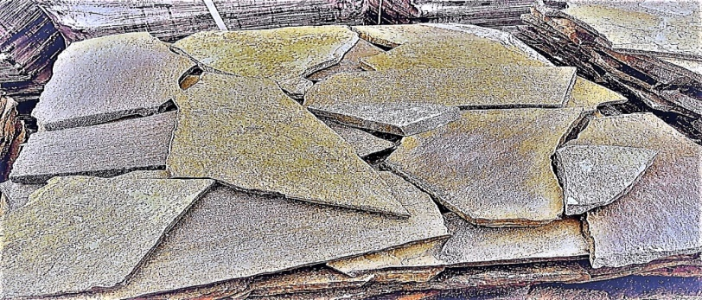 | BULGARIA- --DEREVO  PIATRĂ MĂȘCATA LESPEDE  20-25 PIETRE IN M2  Latime - libera  Lungime - libera  Grosime –2-2.5 cm  Greutate – 35-40 kg/m2  ***MĂSURI APROXIMATIVE | 280LEI/M2—  216 LEI/M2---  27 de rinduri  pe palet  5400 LEI/PALET  ( la раlet)****
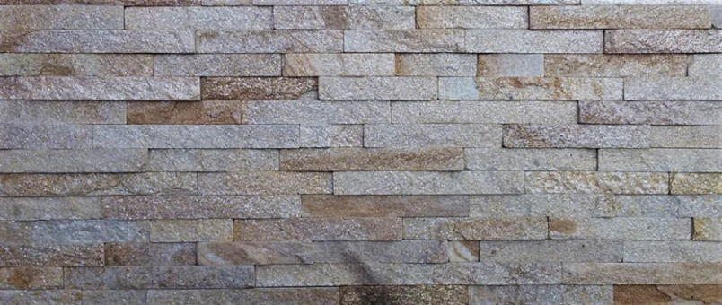 | BULGARIA - DOBRII  LAPSA N-2,5  H-2.5(cm)  Lungime - libera  Grosime –0 .7-1.2cm  Greutate - 10-18kg/m2 | 490LEI/M2
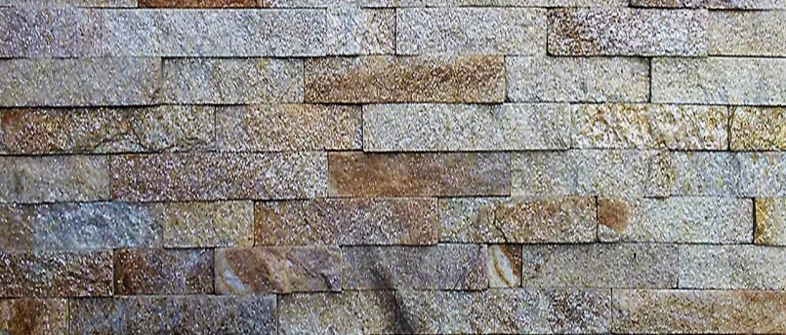 | BULGARIA-----DEREVO  LAPSA N-5  LAPSA N-10  H-5 (cm)  H-10 (cm)  Lungime - libera  Grosime –0 .7-1.2cm  Greutate - 10-18kg/m2 | 540LEI/M2  540LEI/M2
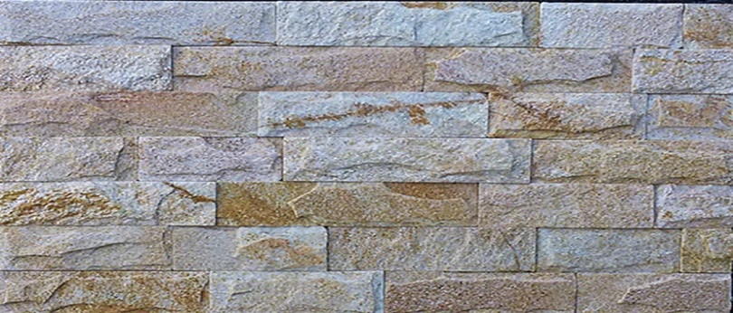 | BULGARIA - DOBRII  SKOL N-5  H-5(cm)  Lungime - libera  Grosime –1-1.5 cm  Greutate - 15-22 kg/m2 | 590LEI/M2
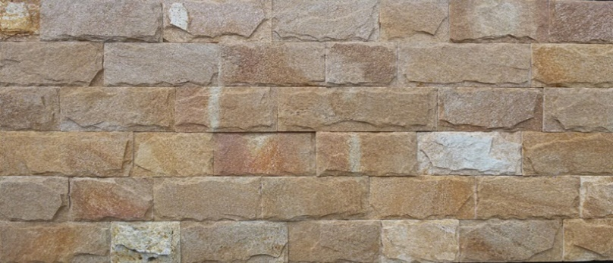 | BULGARIA - DOBRII  SKOL N-10  H-10 (cm)  Lungime - libera  Grosime –1.2-1.8cm  Greutate - 15-22 kg/m2 | 590LEI/M2
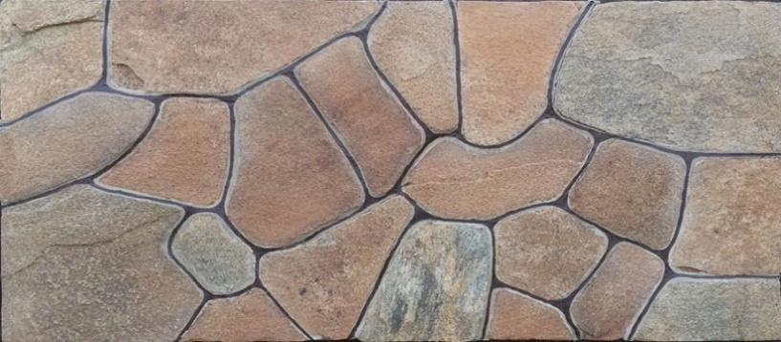 | BULGARIA- DOBRII  PIATRA MĂRUNTĂ LESPEDE  25-40 PIETRE IN M2  Latime - libera  Lungime - libera  Grosime –2-2.5 cm  Greutate – 35-40 kg/m2  ***MĂSURI APROXIMATIVE | 230 LEI/M2  170 LEI/M2---  la раlet  27 de rinduri  pe palet  4250 LEI/PALET  ( la раlet)****
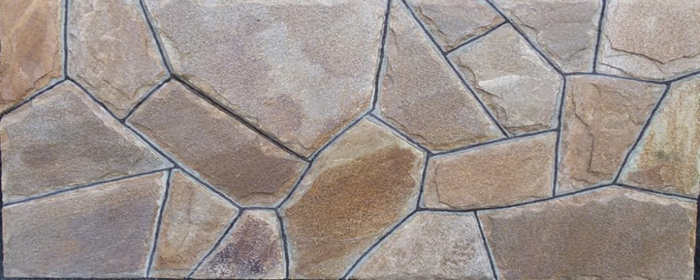 | BULGARIA- DOBRII  PIATRĂ MĂȘCATA LESPEDE  20-25 PIETRE IN M2  Latime - libera  Lungime - libera  Grosime –2-2.5 cm  Greutate – 35-40 kg/m2  ***MĂSURI APROXIMATIVE | 280LEI/M2—  216 LEI/M2---  27 de rinduri  pe palet  5400 LEI/PALET  ( la раlet)****
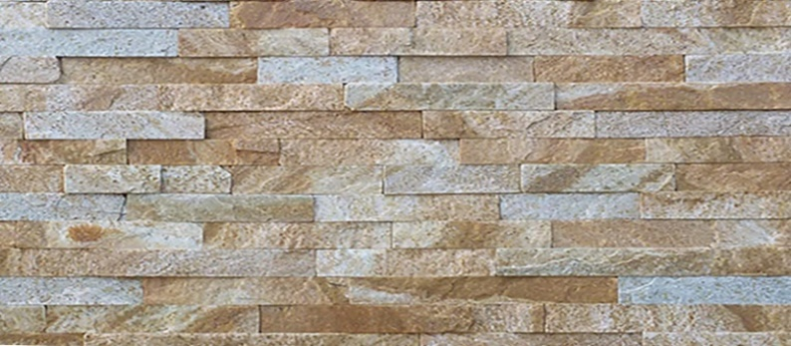 | BULGARIA – GALBUI ROZ  LAPSA N-2,5  H-2.5(cm)  Lungime - libera  Grosime –0 .7-1.2cm  Greutate - 10-18kg/m2 | 490LEI/M2
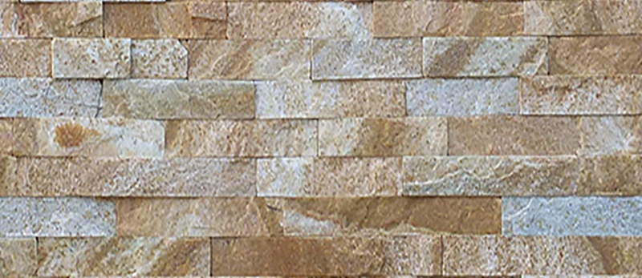 | BULGARIA – GALBUI ROZ  LAPSA N-5  LAPSA N-10  H-5 (cm)  H-10 (cm)  Lungime - libera  Grosime –0 .7-1.2cm  Greutate - 10-18kg/m2 | 540LEI/M2  540LEI/M2
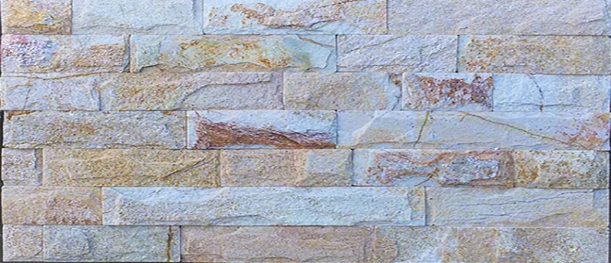 | BULGARIA – GALBUI ROZ  SKOL N-5  H-5(cm)  Lungime - libera  Grosime –1-1.5 cm  Greutate - 15-22 kg/m2 | 590LEI/M2
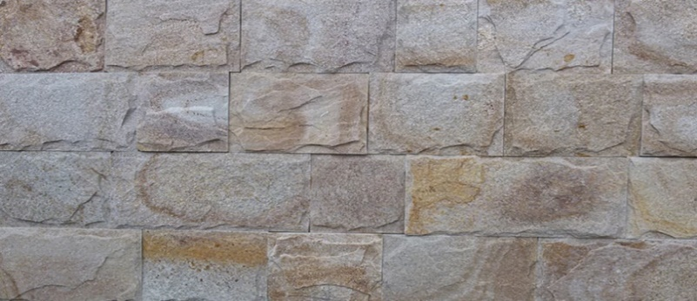 | BULGARIA - GALBUI ROZ  SKOL N-10  H-10 (cm)  Lungime - libera  Grosime –1.2-1.8cm  Greutate - 15-22 kg/m2 | 590LEI/M2
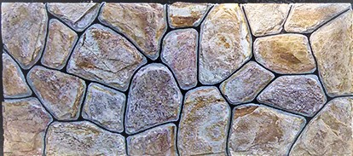 | BULGARIA- GALBUI ROZ  PIATRA MĂRUNTĂ LESPEDE  25-40 PIETRE IN M2  Latime - libera  Lungime - libera  Grosime –2-2.5 cm  Greutate – 35-40 kg/m2  ***MĂSURI APROXIMATIVE | 230 LEI/M2  170 LEI/M2---  la раlet  27 de rinduri  pe palet  4250 LEI/PALET  ( la раlet)****
 | BULGARIA - GALBUI ROZ  PIATRĂ MĂȘCATA LESPEDE  20-25 PIETRE IN M2  Latime - libera  Lungime - libera  Grosime –2-2.5 cm  Greutate – 35-40 kg/m2  ***MĂSURI APROXIMATIVE | 280LEI/M2—  216 LEI/M2---  27 de rinduri  pe palet  5400 LEI/PALET  ( la раlet)****
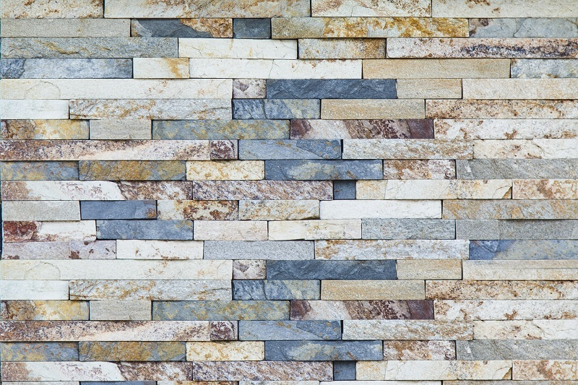 | BULGARIA--ZIMNEA VISNEA  LAPSA N-2,5  H-2.5(cm)  Lungime - libera  Grosime –0 .7-1.2cm  Greutate - 10-18kg/m2 | 490LEI/M2
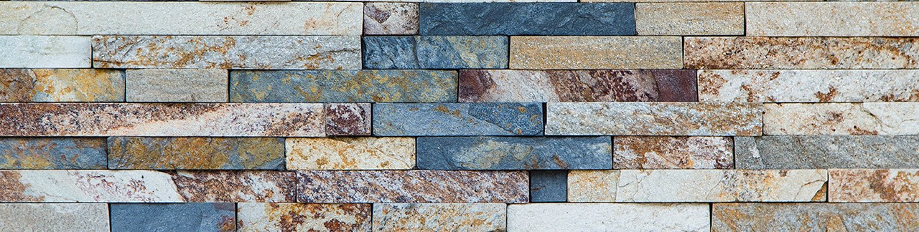 | BULGARIA – ZIMNEA VISNEA  LAPSA N-5  LAPSA N-10  H-5 (cm)  H-10 (cm)  Lungime - libera  Grosime –0 .7-1.2cm  Greutate - 10-18kg/m2 | 540LEI/M2  540LEI/M2
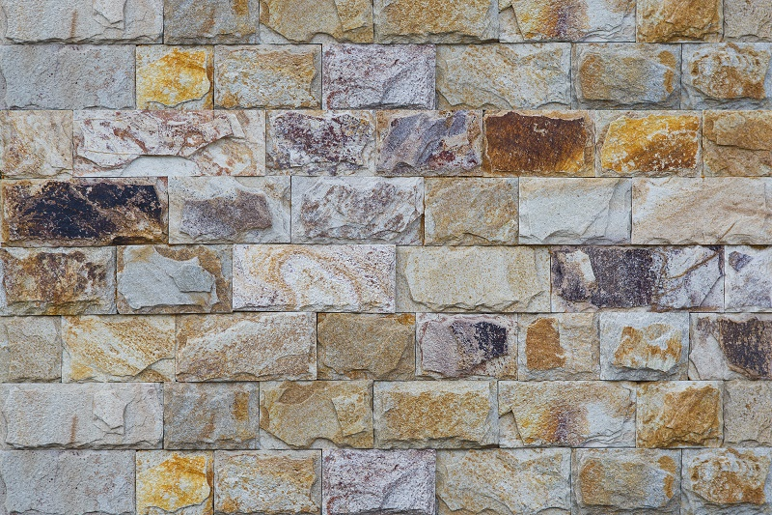 | BULGARI----ZIMNEA VISNEA  SKOL N-5  H-5(cm)  Lungime - libera  Grosime –1-1.5 cm  Greutate - 15-22 kg/m2 | 590LEI/M2
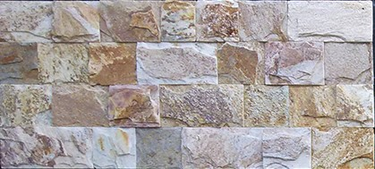 | BULGARIA--ZIMNEA VISNEA  SKOL N-10  H-10(cm)  Lungime - libera  Grosime –1.2-1.8cm  Greutate - 15-22 kg/m2 | 590LEI/M2
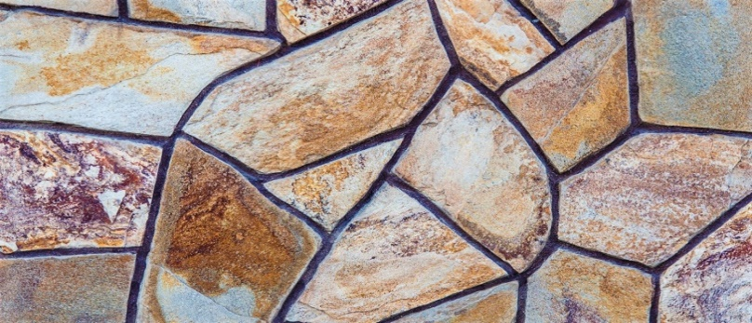 | BULGARIA--ZIMNEA VISNEA  PIATRA MĂRUNTĂ LESPEDE  25-40 PIETRE IN M2  Latime - libera  Lungime - libera  Grosime –2-2.5 cm  Greutate – 35-40 kg/m2  ***MĂSURI APROXIMATIVE | 230 LEI/M2  170 LEI/M2---  la раlet  27 de rinduri  pe palet  4250 LEI/PALET  ( la раlet)****
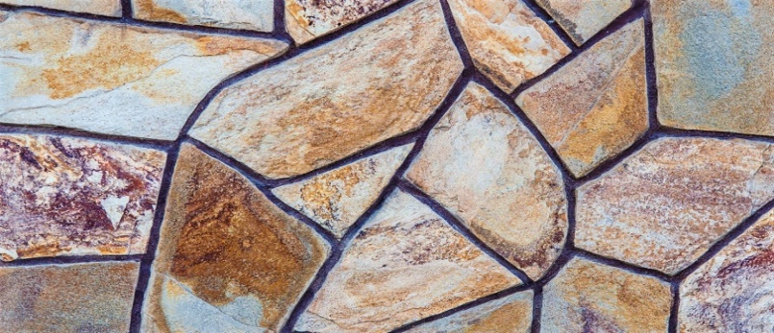 | BULGARIA--ZIMNEA VISNEA  PIATRĂ MĂȘCATA LESPEDE  20-25 PIETRE IN M2  Latime - libera  Lungime - libera  Grosime –2-2.5 cm  Greutate – 35-40 kg/m2  ***MĂSURI APROXIMATIVE | 280LEI/M2—  216 LEI/M2---  27 de rinduri  pe palet  5400 LEI/PALET  ( la раlet)****
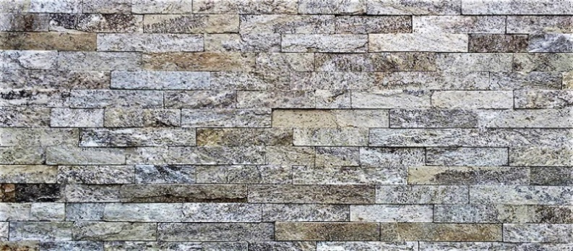 | BULGARIA-CARAMELA  LAPSA N-2,5  H-2.5 (cm)  Lungime - libera  Grosime –0 .7-1.2cm  Greutate - 10-18kg/m2 | 490LEI/M2
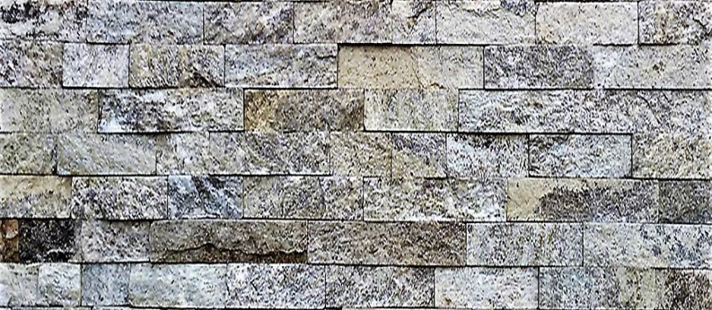 | BULGARIA – CARAMELA  LAPSA N-5  LAPSA N-10  H-5 (cm)  H-10 (cm)  Lungime - libera  Grosime –0 .7-1.2cm  Greutate - 10-18kg/m2 | 540LEI/M2  540LEI/M2
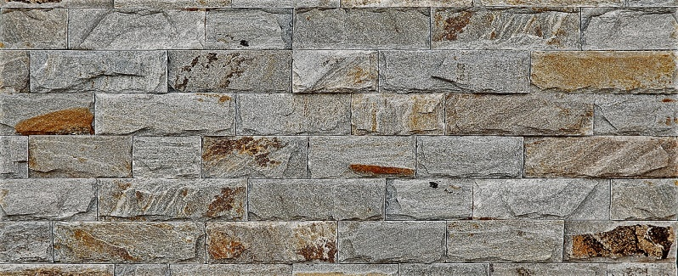 | BULGARIA-CARAMELA  SKOL N-5  H-5(cm)  Lungime - libera  Grosime –1-1.5 cm  Greutate - 15-22 kg/m2 | 590LEI/M2
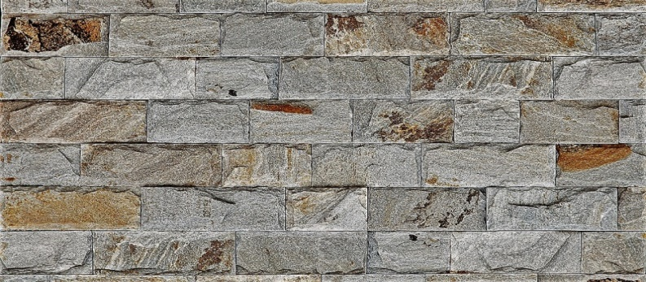 | BULGARIA-CARAMELA  SKOL N-10  H-10(cm)  Lungime - libera  Grosime –1.2-1.8cm  Greutate - 15-22 kg/m2 | 590LEI/M2
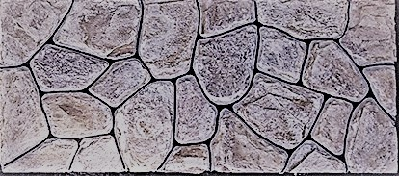 | BULGARIA-- CARAMELA PIATRA MĂRUNTĂ LESPEDE  25-40 PIETRE IN M2  Latime - libera  Lungime - libera  Grosime –2-2.5 cm  Greutate – 35-40 kg/m2  ***MĂSURI APROXIMATIVE | 230 LEI/M2  170 LEI/M2---  la раlet  27 de rinduri  pe palet  4250 LEI/PALET  ( la раlet)****
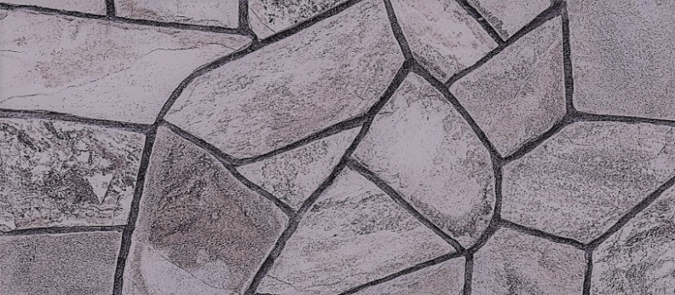 | BULGARIA-- CARAMELA  PIATRĂ MĂȘCATA LESPEDE  20-25 PIETRE IN M2  Latime - libera  Lungime - libera  Grosime –2-2.5 cm  Greutate – 35-40 kg/m2  ***MĂSURI APROXIMATIVE | 280LEI/M2—  216 LEI/M2---  27 de rinduri  pe palet  5400 LEI/PALET  ( la раlet)****
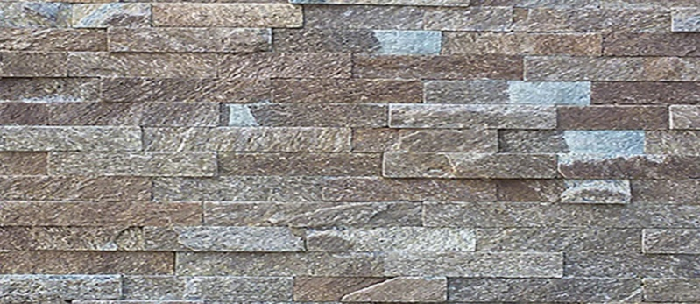 | BULGARIA-MEDVEJIA SCURA  LAPSA N-2,5  H-2.5 (cm)  Lungime - libera  Grosime –0 .7-1.2cm  Greutate - 10-18kg/m2 | 490LEI/M2
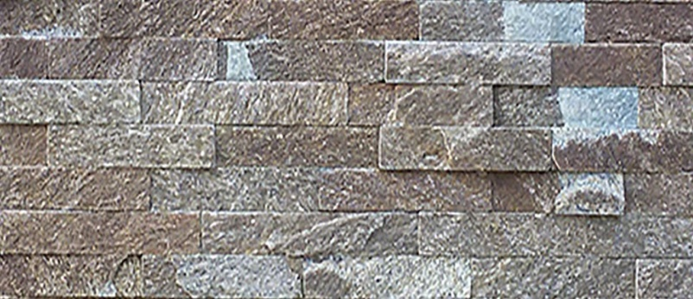 | BULGARIA-MEDVEJIA SCURA  LAPSA N-5  LAPSA N-10  H-5 (cm)  H-10 (cm)  Lungime - libera  Grosime –0 .7-1.2cm  Greutate - 10-18kg/m2 | 540LEI/M2  540LEI/M2
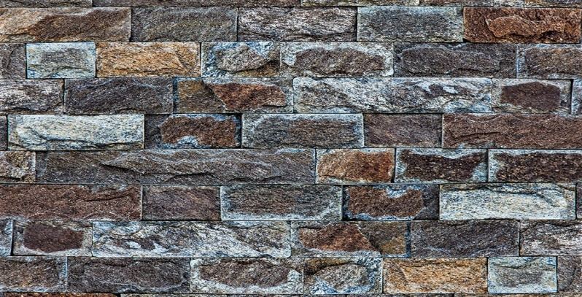 | BULGARIA-MEDVEJIA SCURA  SKOL N-5  H-5(cm)  Lungime - libera  Grosime –1-1.5 cm  Greutate - 15-22 kg/m2 | 590LEI/M2
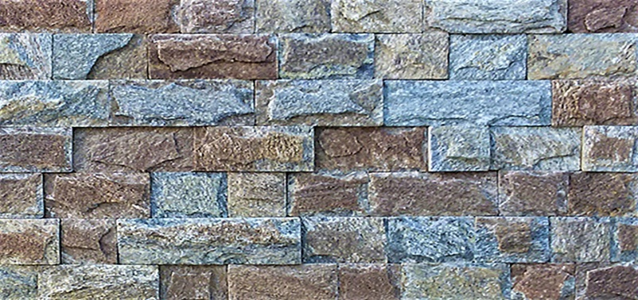 | BULGARIA-MEDVEJIA SCURA  SKOL N-10  H-10(cm)  Lungime - libera  Grosime –1.2-1.8cm  Greutate - 15-22 kg/m2 | 590LEI/M2
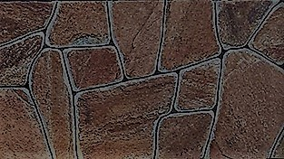 | BULGARIA-MEDVEJIA SCURA PIATRA MĂRUNTĂ LESPEDE  25-40 PIETRE IN M2  Latime - libera  Lungime - libera  Grosime –2-2.5 cm  Greutate – 35-40 kg/m2  ***MĂSURI APROXIMATIVE | 230 LEI/M2  170 LEI/M2---  la раlet  27 de rinduri  pe palet  4250 LEI/PALET  ( la раlet)****
 | BULGARIA-MEDVEJIA SCURA  PIATRĂ MĂȘCATA LESPEDE  20-25 PIETRE IN M2  Latime - libera  Lungime - libera  Grosime –2-2.5 cm  Greutate – 35-40 kg/m2  ***MĂSURI APROXIMATIVE | 280LEI/M2—  216 LEI/M2---  27 de rinduri  pe palet  5400 LEI/PALET  ( la раlet)****
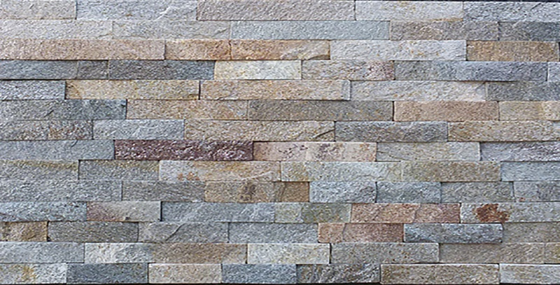 | BULGARIA---- SUR VISINIU  LAPSA N-2,5  H-2.5 (cm)  Lungime - libera  Grosime –0 .7-1.2cm  Greutate - 10-18kg/m2 | 490LEI/M2
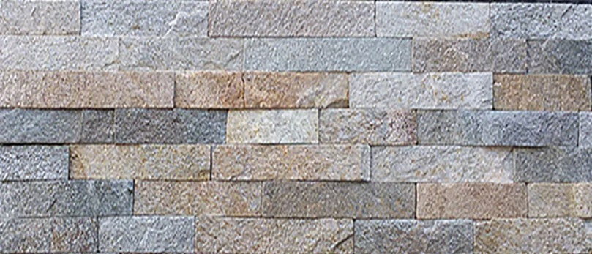 | BULGARIA---- SUR VISINIU  LAPSA N-5  LAPSA N-10  H-5 (cm)  H-10 (cm)  Lungime - libera  Grosime –0 .7-1.2cm  Greutate - 10-18kg/m2 | 540LEI/M2  540LEI/M2
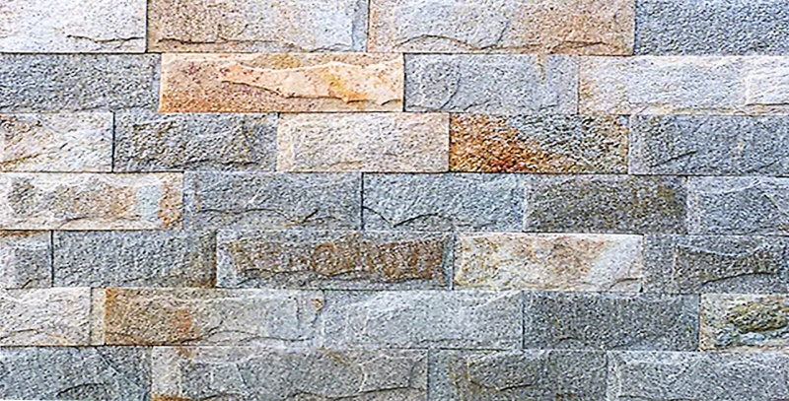 | BULGARIA----SUR VISINIU  SKOL N-5  H-5(cm)  Lungime - libera  Grosime –1-1.5 cm  Greutate - 15-22 kg/m2 | 590LEI/M2
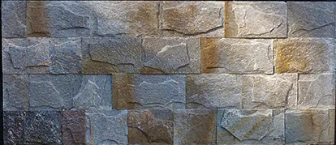 | BULGARIA----SUR VISINIU  SKOL N-10  H-10(cm)  Lungime - libera  Grosime –1.2-1.8cm  Greutate - 15-22 kg/m2 | 590LEI/M2
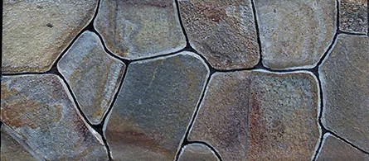 | BULGARIA----SUR VISINIU  PIATRA MĂRUNTĂ LESPEDE  25-40 PIETRE IN M2  Latime - libera  Lungime - libera  Grosime –2-2.5 cm  Greutate – 35-40 kg/m2  ***MĂSURI APROXIMATIVE | 230 LEI/M2  170 LEI/M2---  la раlet  27 de rinduri  pe palet  4250 LEI/PALET  ( la раlet)****
 | BULGARIA- SUR VISINIU  PIATRĂ MĂȘCATA LESPEDE  20-25 PIETRE IN M2  Latime - libera  Lungime - libera  Grosime –2-2.5 cm  Greutate – 35-40 kg/m2  ***MĂSURI APROXIMATIVE | 280LEI/M2—  216 LEI/M2---  27 de rinduri  pe palet  5400 LEI/PALET  ( la раlet)****
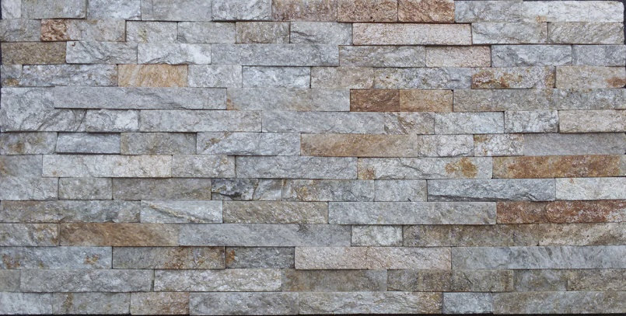 | BULGARIA-SLIUDOVII ASORTI  LAPSA N-2,5  H-2.5 (cm)  Lungime - libera  Grosime –0 .7-1.2cm  Greutate - 10-18kg/m2 | 490LEI/M2
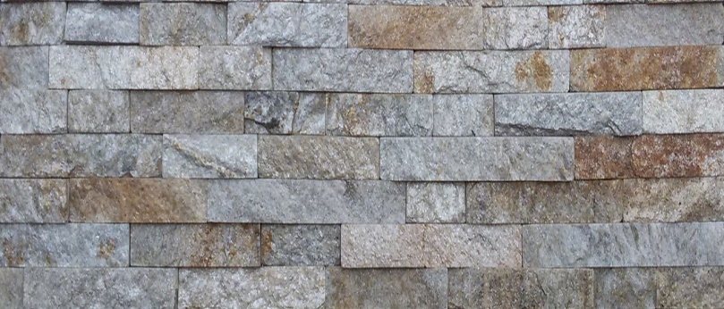 | BULGARIA-SLIUDOVII ASORTI  LAPSA N-5  LAPSA N-10  H-5 (cm)  H-10 (cm)  Lungime - libera  Grosime –0 .7-1.2cm  Greutate - 10-18kg/m2 | 540LEI/M2  540LEI/M2
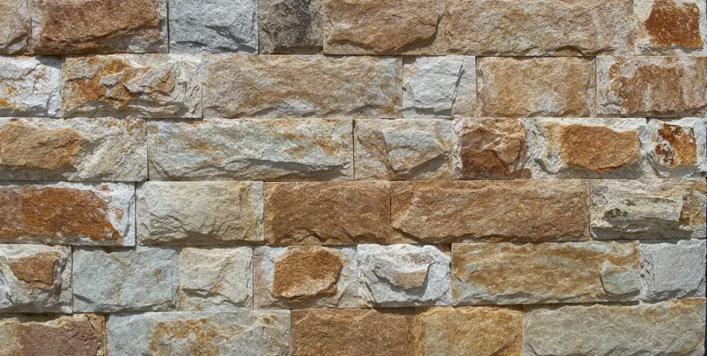 | BULGARIA-SLIUDOVII ASORTI  SKOL N-5  H-5(cm)  Lungime - libera  Grosime –1-1.5 cm  Greutate - 15-22 kg/m2 | 590LEI/M2
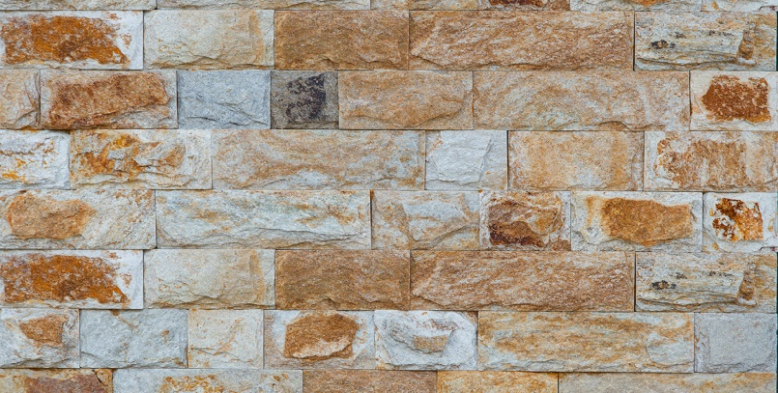 | BULGARIA-SLIUDOVII ASORTI  SKOL N-10  H-10(cm)  Lungime - libera  Grosime –1.2-1.8cm  Greutate - 15-22 kg/m2 | 590LEI/M2
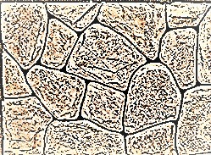 | BULGARIA-SLIUDOVII ASORTI  PIATRA MĂRUNTĂ LESPEDE  25-40 PIETRE IN M2  Latime - libera  Lungime - libera  Grosime –2-2.5 cm  Greutate – 35-40 kg/m2  ***MĂSURI APROXIMATIVE | 230 LEI/M2  170 LEI/M2---  la раlet  27 de rinduri  pe palet  4250 LEI/PALET  ( la раlet)****
 | BULGARIA-SLIUDOVII ASORTI PIATRĂ MĂȘCATA LESPEDE  20-25 PIETRE IN M2  Latime - libera  Lungime - libera  Grosime –2-2.5 cm  Greutate – 35-40 kg/m2  ***MĂSURI APROXIMATIVE | 280LEI/M2—  216 LEI/M2---  27 de rinduri  pe palet  5400 LEI/PALET  ( la раlet)****  ( la раlet)****
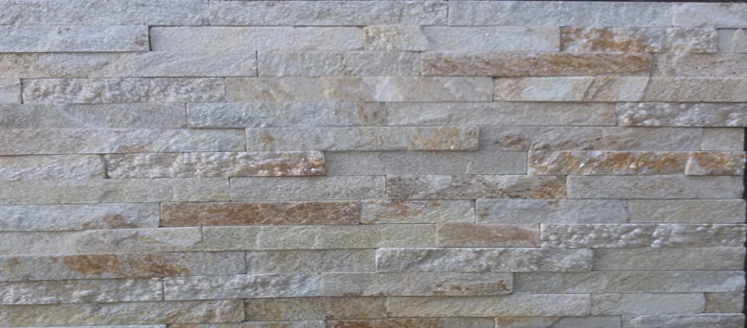 | BULGARIA- SLIUDOVII  LAPSA N-2.5  H-2.5 (cm)  Lungime - libera  Grosime –0 .7-1.2cm  Greutate - 10-18kg/m2 | 490LEI/M2
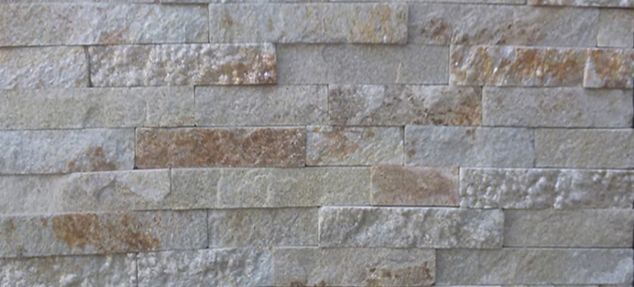 | BULGARIA-SLIUDOVII  LAPSA N-5  LAPSA N-10  H-5 (cm)  H-10 (cm)  Lungime - libera  Grosime –0 .7-1.2cm  Greutate - 10-18kg/m2 | 540LEI/M2  540LEI/M2
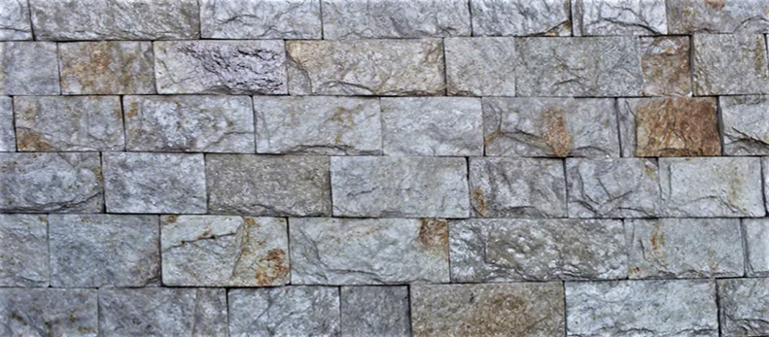 | BULGARIA- SLIUDOVII  SKOL N-5  H-5(cm)  Lungime - libera  Grosime –1-1.5 cm  Greutate - 25-30 kg/m2 | 590LEI/M2
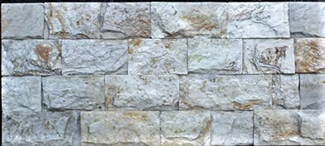 | BULGARIA- SLIUDOVII  SKOL N-10  H-10(cm)  Lungime - libera  Grosime –1.2-1.8cm  Greutate - 25-30 kg/m2 | 590LEI/M2
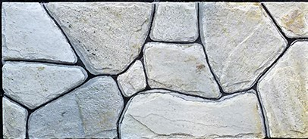 | BULGARIA- SLIUDOVII PIATRA MĂRUNTĂ LESPEDE  25-40 PIETRE IN M2  Latime - libera  Lungime - libera  Grosime –2-2.5 cm  Greutate – 35-40 kg/m2  ***MĂSURI APROXIMATIVE | 230 LEI/M2  170 LEI/M2---  la раlet  27 de rinduri  pe palet  4250 LEI/PALET  ( la раlet)****
 | BULGARIA- SLIUDOVII  PIATRĂ MĂȘCATA LESPEDE  20-25 PIETRE IN M2  Latime - libera  Lungime - libera  Grosime –2-2.5 cm  Greutate – 35-40 kg/m2 | 280LEI/M2—  216 LEI/M2---  27 de rinduri  pe palet  5400 LEI/PALET  ( la раlet)****
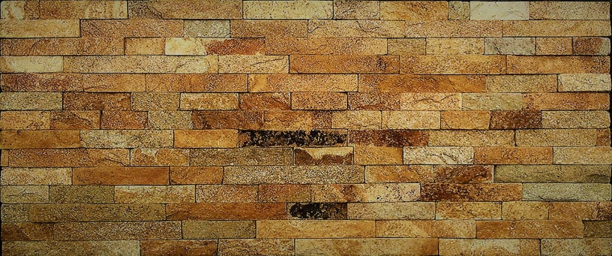 | BULGARIA-- STAROE ZOLOTO  LAPSA N-2,5  H-2.5 (cm)  Lungime - libera  Grosime –0 .7-1.2cm  Greutate - 10-18kg/m2 | 490LEI/M2
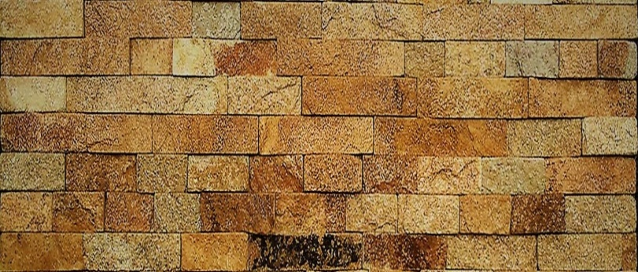 | BULGARIA-- STAROE ZOLOTO  LAPSA N-5  LAPSA N-10  H-5 (cm)  H-10 (cm)  Lungime - libera  Grosime –0 .7-1.2cm  Greutate - 10-18kg/m2 | 540LEI/M2  540LEI/M2
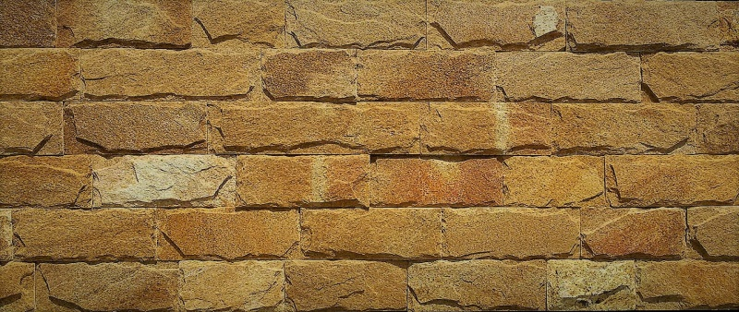 | BULGARIA-- STAROE ZOLOTO  SKOL N-5  SKOL N-10  H-5 (cm)  H-10(cm)  Lungime - libera  Grosime –1.2-1.8cm  Greutate - 25-30 kg/m2 | 590LEI/M2
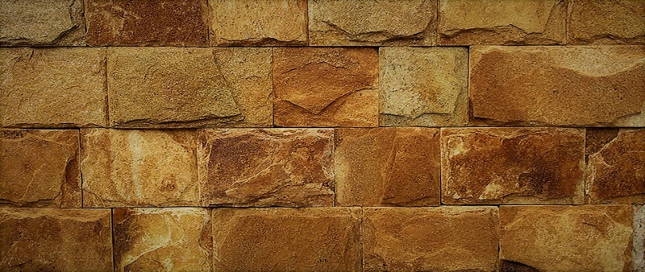 | BULGARIA--STAROE ZOLOTO  SKOL N-15  H-15 (cm)  Lungime - libera  Grosime –1.2-1.8cm  Greutate - 25-30 kg/m2 | 590LEI/M2
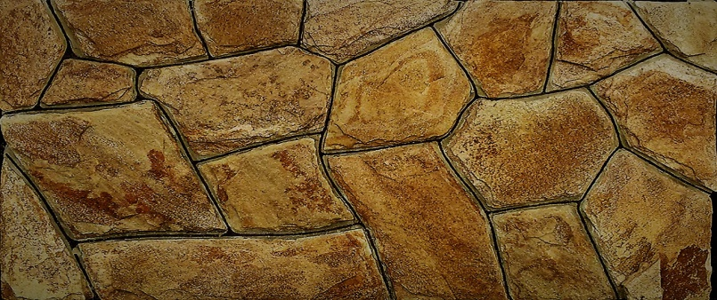 | BULGARIA-STAROE ZOLOTO  PIATRA MĂRUNTĂ LESPEDE  25-40 PIETRE IN M2  Latime - libera  Lungime - libera  Grosime –2-2.5 cm  Greutate – 35-40 kg/m2  ***MĂSURI APROXIMATIVE | 230 LEI/M2  170 LEI/M2---  la раlet  27 de rinduri  pe palet  4250 LEI/PALET  ( la раlet)****
 | BULGARIA- STAROE ZOLOTO  PIATRĂ MĂȘCATA LESPEDE  20-25 PIETRE IN M2  Latime - libera  Lungime - libera  Grosime –2-2.5 cm  Greutate – 35-40 kg/m2 | 280LEI/M2—  216 LEI/M2---  27 de rinduri  pe palet  5400 LEI/PALET  ( la раlet)****
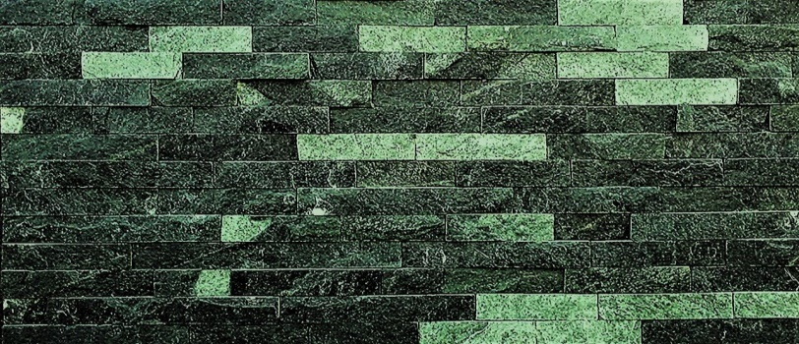 | BULGARIA----VERDE  LAPSA N-2,5  H-2.5 (cm)  Lungime - libera  Grosime –0 .7-1.2cm  Greutate – 15-20 kg/m2 | 490LEI/M2
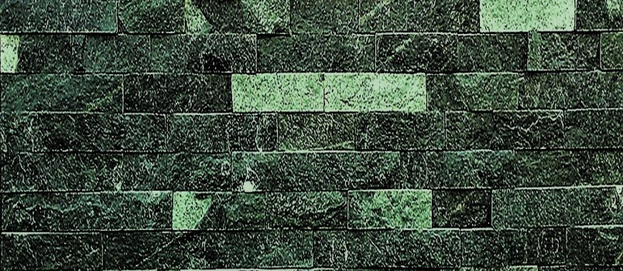 | BULGARIA-- VERDE  LAPSA N-5  LAPSA N-10  H-5 (cm)  H-10 (cm)  Lungime - libera  Grosime –0 .7-1.2cm  Greutate - 10-18kg/m2 | 540LEI/M2  540LEI/M2
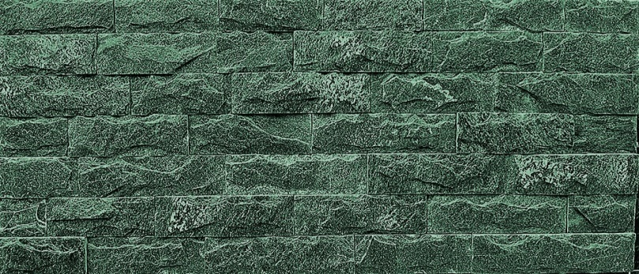 | BULGARIA----VERDE  SKOL N-5  H-5(cm)  Lungime - libera  Grosime –1-1.5 cm  Greutate - 15-22 kg/m2 | 590LEI/M2
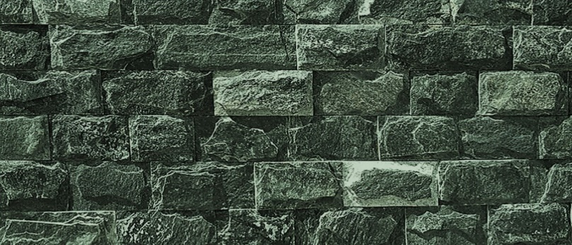 | BULGARIA---VERDE  SKOL N-10  H-10(cm)  Lungime - libera  Grosime –1.2-1.8cm  Greutate - 15-22 kg/m2 | 590LEI/M2
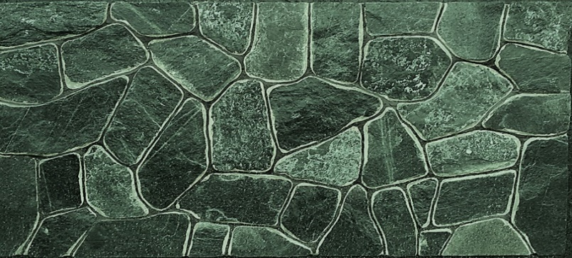 | BULGARIA----VERDE  PIATRA MĂRUNTĂ LESPEDE  25-40 PIETRE IN M2  Latime - libera  Lungime - libera  Grosime –2-2.5 cm  Greutate – 35-40 kg/m2  ***MĂSURI APROXIMATIVE | 230 LEI/M2  170 LEI/M2---  la раlet  27 de rinduri  pe palet  4250 LEI/PALET  ( la раlet)****
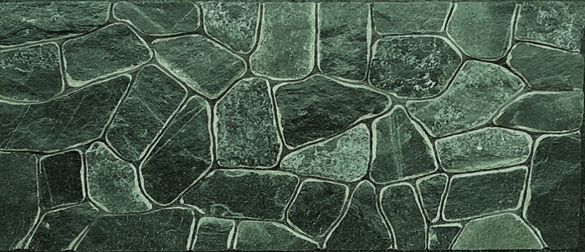 | BULGARIA----VERDE  PIATRĂ MĂȘCATA LESPEDE  20-25 PIETRE IN M2  Latime - libera  Lungime - libera  Grosime –2-2.5 cm  Greutate – 35-40 kg/m2 | 280LEI/M2—  216 LEI/M2---  27 de rinduri  pe palet  5400 LEI/PALET  ( la раlet)****
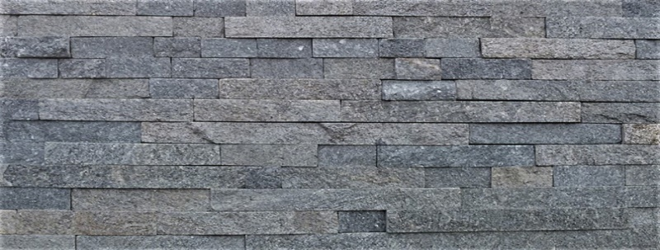 | BULGARIA---METALIC  LAPSA N-2,5  H-2.5(cm)  Lungime - libera  Grosime –0 .7-1.2cm  Greutate - 10-18kg/m2 | 490LEI/M2
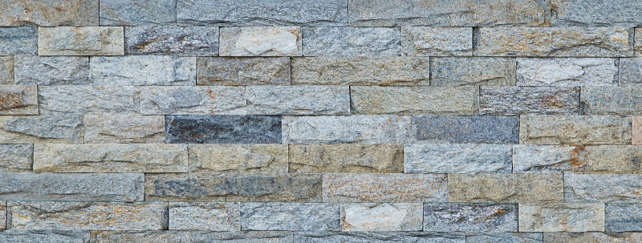 | BULGARIA---METALIC  SKOL N-5  H-5(cm)  Lungime - libera  Grosime –0 .7-1.5cm  Greutate – 15-20 kg/m2 | 590LEI/M2
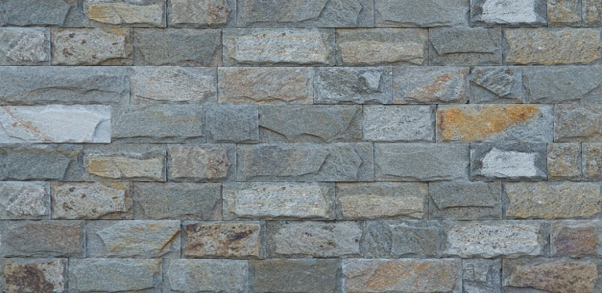 | BULGARIA----METALIC  SKOL N-10  H-10(cm)  Lungime - libera  Grosime –1.2-1.8cm  Greutate - 15-20 kg/m2 | 590LEI/M2
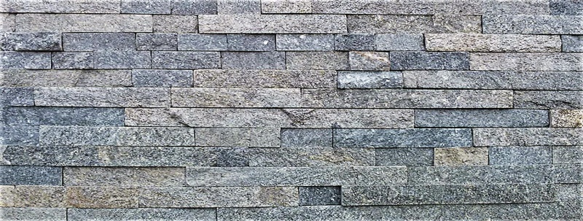 | GREGIA---KAVALA  LAPSA N-2,5  H-2.5(cm)  Lungime - libera  Grosime –0 .7-1.2cm  Greutate - 15-20 kg/m2 | 490 LEI/M2
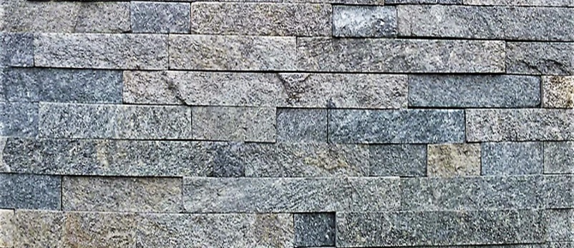 | GREGIA---KAVALA  LAPSA N-5  LAPSA N-10  LAPSA N-15  LAPSA N-20  Lungime - libera  Grosime –0 .7-1.2cm  Greutate - 10-18kg/m2 | 540LEI/M2  540LEI/M2  540LEI/M2  540LEI/M2
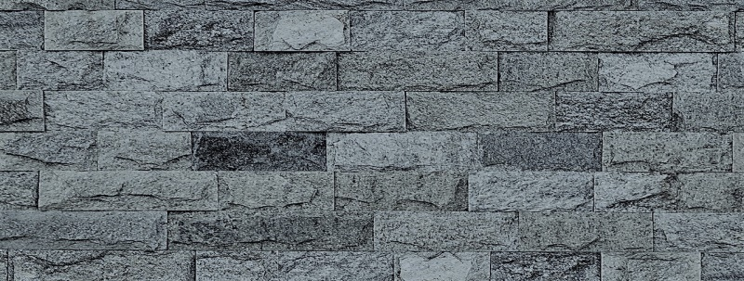 | GREGIA---KAVALA  SKOL N-5  SKOL N-10  SKOL N-15  SKOL N-20  H-5(cm)  Lungime - libera  Grosime –1-1.5 cm  Greutate - 15-22 kg/m2 | 590 LEI/M2  590 LEI/M2  590 LEI/M2  590 LEI/M2
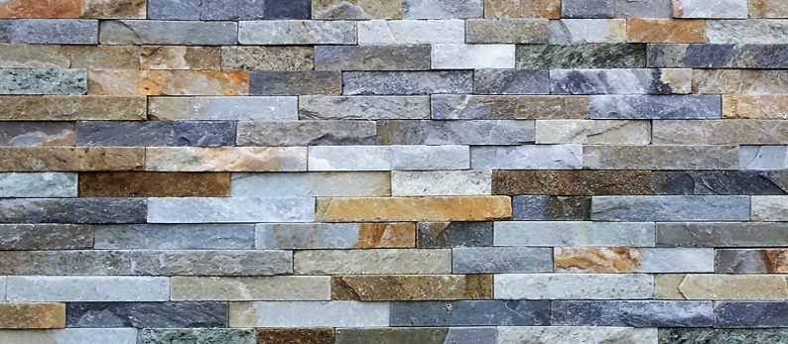 | GREGIA ---MULITICOLOR  LAPSA N-2,5  H-2.5(cm)  Lungime - libera  Grosime –0 .7-1.2cm  Greutate - 15-20 kg/m2 | 490 LEI/M2
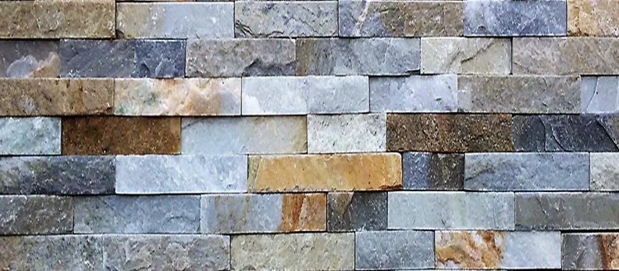 | GREGIA ---MULITICOLOR  LAPSA N-5  LAPSA N-10  LAPSA N-15  LAPSA N-20  Lungime - libera  Grosime –0 .7-1.2cm  Greutate - 10-18kg/m2 | 540LEI/M2  540LEI/M2  540LEI/M2  540LEI/M2
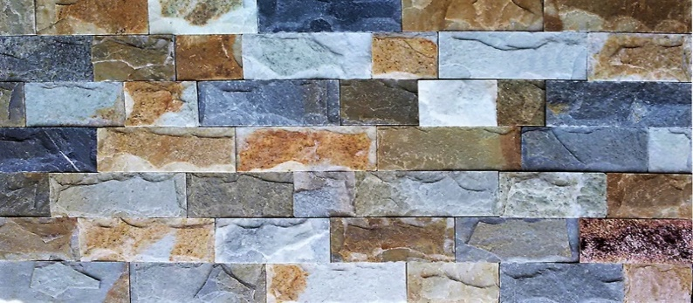 | GREGIA MULITICOLOR  SKOL N-5  H-5 (cm)  Lungime - libera  Grosime –0 .7-1.5cm  Greutate - 25-30 kg/m2 | 590 LEI/M2
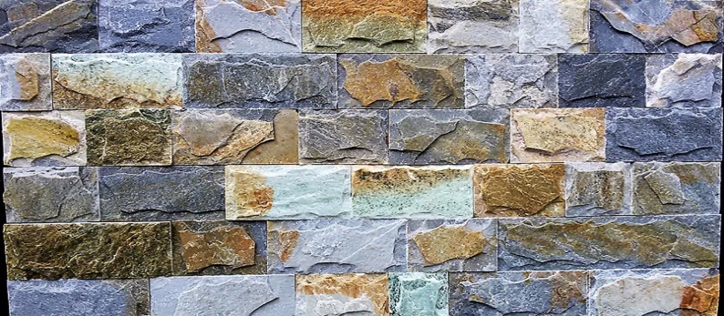 | GREGIA MULITICOLOR  SKOL N-10  SKOL N-15  SKOL N-20  H-10 (cm) H-15(cm) 20(cm)  Lungime - libera  Grosime –1.2-1.8cm  Greutate - 30-40 kg/m2 | 590 LEI/M2  590 LEI/M2  590 LEI/M2
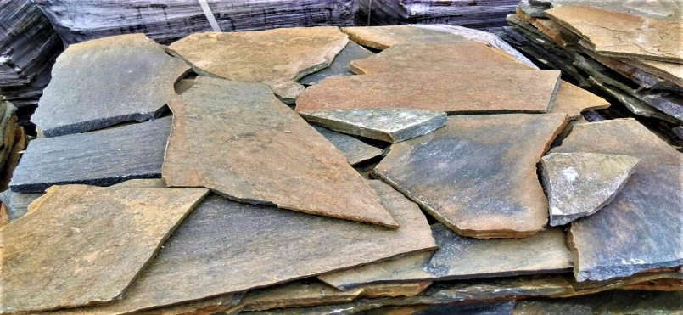 | GREGIA---MULITICOLOR  PIATRĂ MĂȘCATA LESPEDE  15-20 PIETRE IN M2  Latime - libera  Lungime - libera  Grosime –2-2.5 cm  Greutate – 35-40 kg/m2 | 280LEI/M2—--  250 LEI/M2---  --PALET - 30 M2  7500 LEI/PALET  PRET—ANGRO  ( la раlet)****
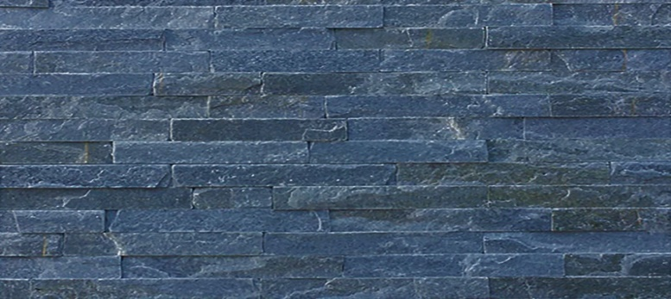 | GREGIA--iNDIGO  LAPSA N-2,5  H-2.5(cm)  Lungime - libera  Grosime –0 .7-1.2cm  Greutate - 15-20 kg/m2 | 490 LEI/M2
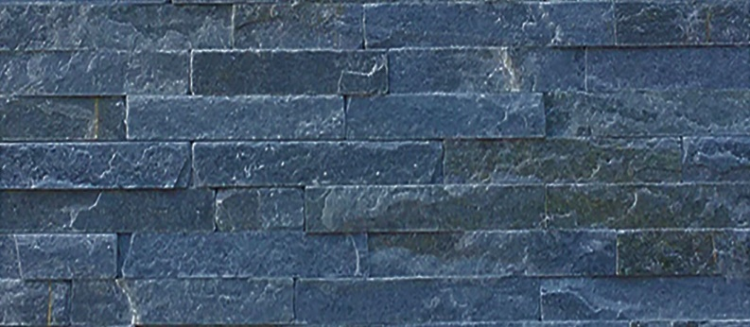 | GREGIA---INDIGO  LAPSA N-5  LAPSA N-10  H-5 (cm)  H-10 (cm)  Lungime - libera  Grosime –0 .7-1.2cm  Greutate - 10-18kg/m2 | 540LEI/M2  540LEI/M2
 | GREGIA---INDIGO  SKOL N-5  SKOL N-10  SKOL N-15  SKOL N-20  H-5/H-10 / H-15/ H-20(cm)  Lungime - libera  Grosime –1.2-1.8cm  Greutate - 30-40 kg/m2 | 590 LEI/M2  590 LEI/M2  590 LEI/M2  590 LEI/M2
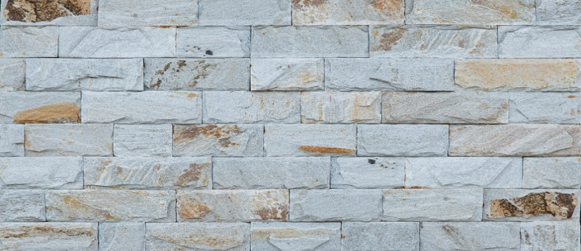 | BULGARIA---ARGINTIU  SKOL N-10  H-5(cm)  Lungime - libera  Grosime –1.2-1.8cm  Greutate - 10-18kg/m2 | 590LEI/M2
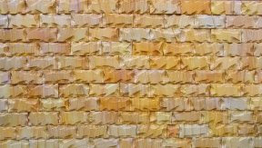 | INDIA TEAK -- RANBOU  SKOL N-4.5  H-4.5 (cm)  Lungime - 10/15 cm  Grosime –1-1.2 cm  Greutate - 15-20 kg/m2 | 650 LEI/M2
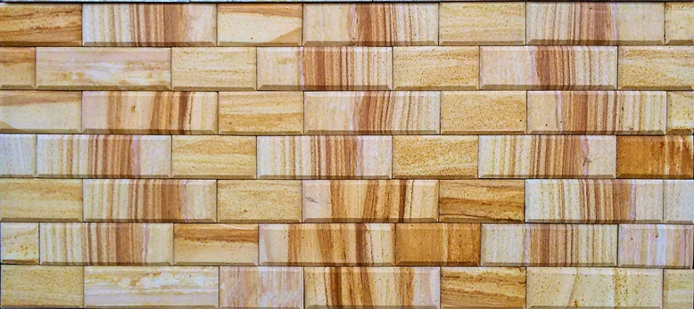 | INDIA-- TEAK  4.5х20 4,5х15 4,5х10  H-4.5 (cm)  Lungime - 10/15/20 cm  Grosime –1.5 cm  Greutate - 15-20 kg/m2 | 650 LEI/M2
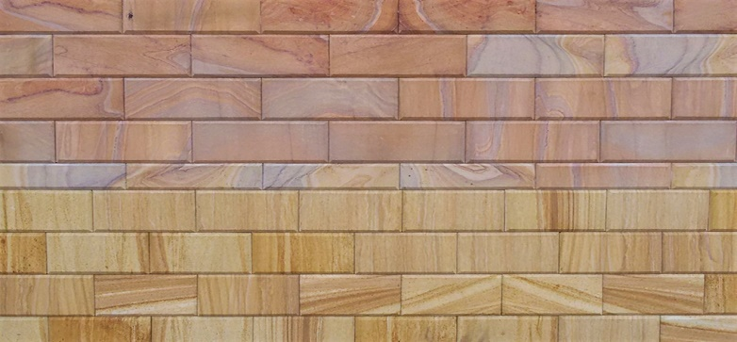 | INDIA TEAK -RANBOU  7х15  H-7.5 (cm)  Lungime - 15 cm  Grosime –1.5 cm  Greutate - 15-20 kg/m2 | 650 LEI/M2
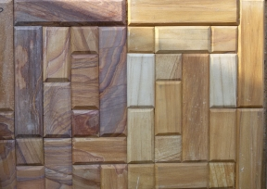 | INDIA TEAK RANBOU  H-10 (cm)  Lungime - 10-20-40  Grosime –1.5cm  Greutate - 10-18kg/m2 | 650LEI
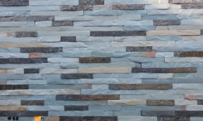 | INDIA VERDE+DEOLEGRI  LAPSA N-2,5  H-2.5(cm)  Lungime - libera  Grosime –0 .7-1.2 cm  Greutate -12-18 kg/m2 | 650 LEI/M2
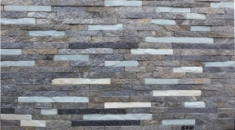 | INDIA VERDE+DEOLEGRI  LAPSA N-2,5  H-2.5(cm)  Lungime - libera  Grosime –0 .7-1.2 cm  Greutate - 12-18 kg/m2 | 650 LEI/M2
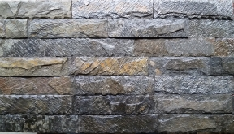 | INDIA DEOLEGRI  SKOL N-7  H- 7(cm)  Lungime - libera  Grosime –1,2-1.8cm  Greutate - 15-25kg/m2 | 650 LEI/M2
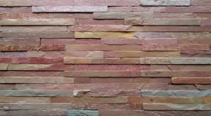 | INDIA ROZ  LAPSA N-2,5  H-2.5(cm)  Lungime - libera  Grosime –0 .7-1.2cm  Greutate - 10-18kg/m2 | 650 LEI/M2
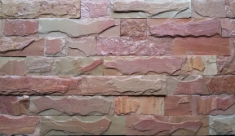 | INDIA ROZ  SKOL N-7  H- 7(cm)  Lungime - libera  Grosime –0 .7-1.2 cm  Greutate - 15-25 kg/m2 | 650 LEI/M2
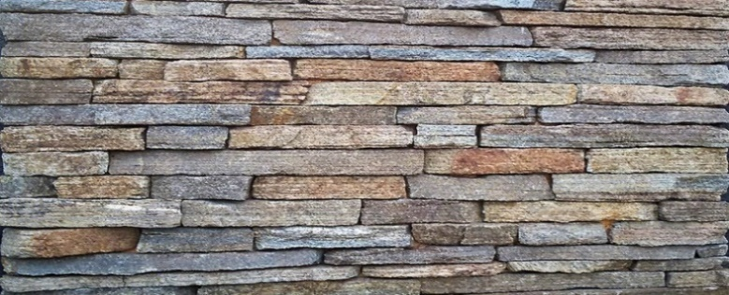 | BULGARIA--CAPTE  CAPTE TAIETE  H-2---2.5 (cm)  Lungime - libera  Greutate – 15-20 kg/m2 | 250 LEI/M2
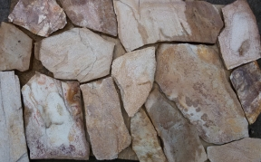 | BULGARIA  PIATRĂ MĂȘCATA LESPEDE  20-25 PIETRE IN M2  ***MĂSURI APROXIMATIVE  1m2-- 20-25 pietre  H- libera  Lungime - libera  Grosime –1.5-2.5cm  Greutate - 25-30kg/m2  ***MĂSURI APROXIMATIVE | 280LEI/M2—--  216 LEI/M2---  --PALET - 30 M2  5400 LEI/PALET  PRET—ANGRO  ( la раlet)****
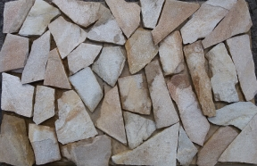 | BULGARIA  PIATRA MĂRUNTĂ LESPEDE  25-40 PIETRE IN M2  ***MĂSURI APROXIMATIVE  1m2-- 25-40 pietre  H- libera  Lungime - libera  Grosime –1.5-2.5cm  Greutate - 25-30kg/m2  ***MĂSURI APROXIMATIVE | 230 LEI/M2  170 LEI/M2---  la раlet  27 de rinduri  pe palet  4250 LEI/PALET  ( la раlet)****
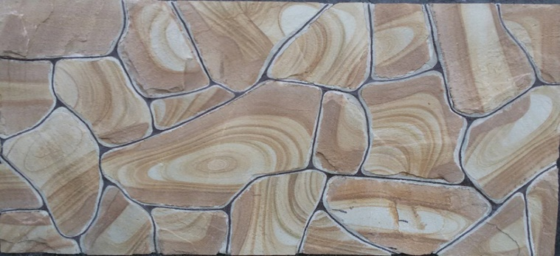 | RUSIA ROSTOV  PIATRĂ MĂȘCATA LESPEDE  20-25 PIETRE IN M2  Latime - libera  Lungime - libera  Grosime –2-2.5 cm  Greutate – 35-40 kg/m2  ***MĂSURI APROXIMATIVE | 280 LEI/M2
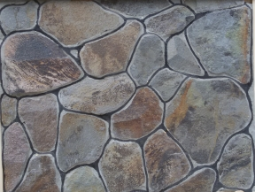 | UCRAINA--ANDEZIT  PIATRĂ MĂȘCATA LESPEDE  20-25 PIETRE IN M2  Latime - libera  Lungime - libera  Grosime –2-2.5 cm  Greutate – 35-40 kg/m2  ***MĂSURI APROXIMATIVE | 180 LEI/M2---  la раlet  32 de rinduri pe palet  5400 LEI/PALET  ( la раlet)****
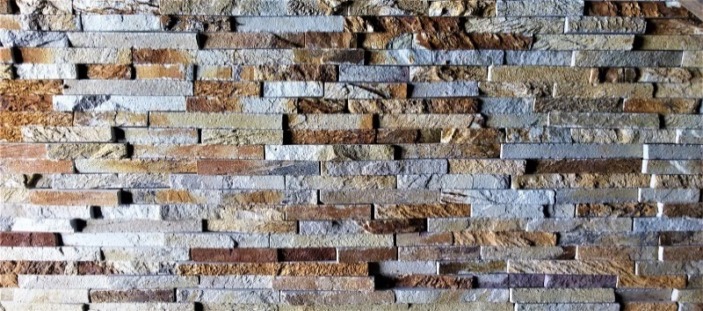 | UNGARIA--LEPARIT  LAPSA N-2,5  H-2.5(cm)  Lungime - libera  Grosime –1-1.8cm  Greutate - 15-20 kg/m2 | 490 LEI/M2
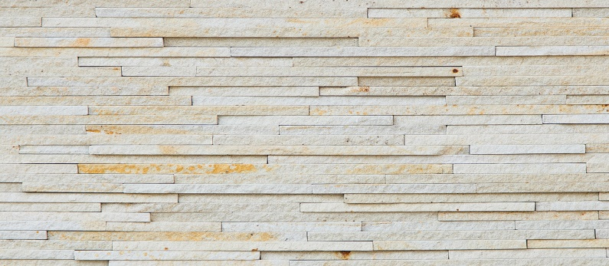 | LAPSA DESPICATA  N-1-COSAUTI  H-1 (cm)  Lungime - libera  Grosime – 1-1.5 (cm)  Greutate - 20-25 kg/m2 | 200 lei/m2
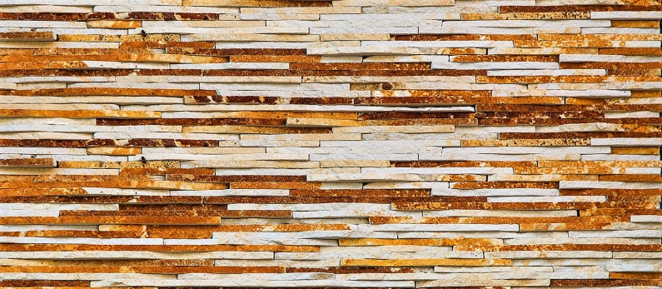 | LAPSA TAIATA  N-1-COSAUTI  H-1 (cm)  Lungime - libera  Grosime – 1-1.5 (cm)  Greutate - 25-30 kg/m2 | 230 lei/m2
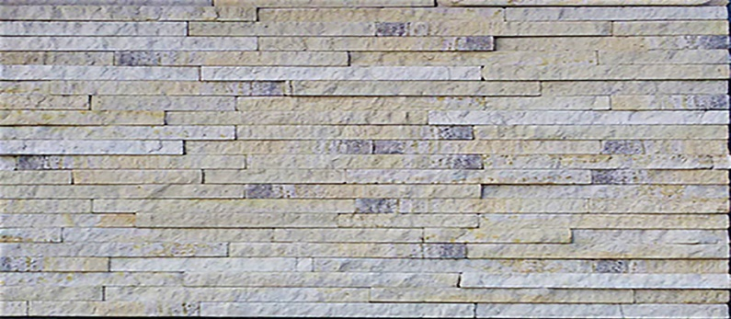 | LAPSA DESPICATA  N-1.5-COSAUTI  H-1.5 (cm)  Lungime - libera  Grosime -1- 1.5 (cm)  Greutate - 22-28 kg/m2 | 200 lei/m2
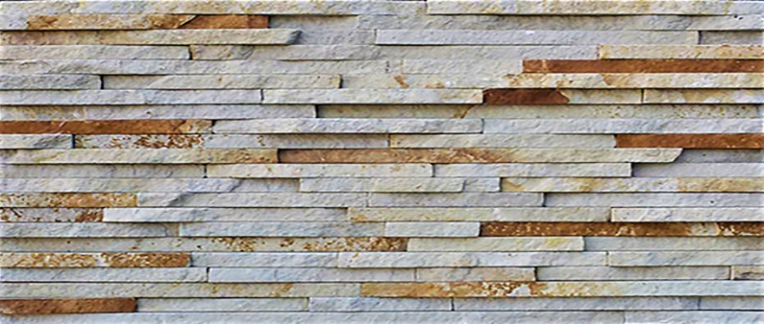 | LAPSA TAIATA  N-1.5- COSAUTI  H-1.5 (cm)  Lungime - libera  Grosime -1.5- 2 (cm)  Greutate - 27-32 kg/m2 | 225 lei/m2
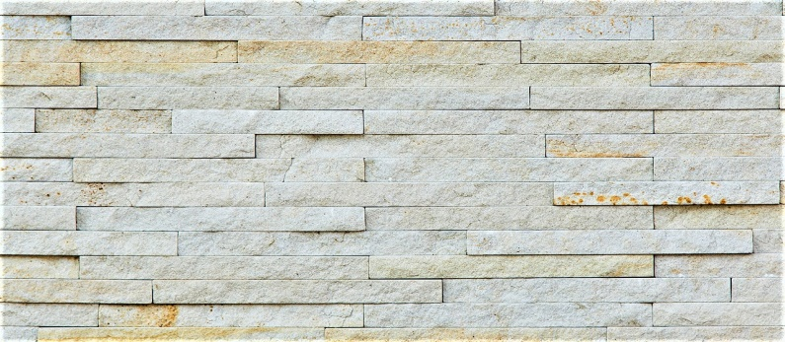 | LAPSA DESPICATA  N-2-COSAUTI  H-2 (cm)  Lungime - libera  Grosime -1- 1.8 (cm)  Greutate - 25-30 kg/m2 | 200 lei/m2
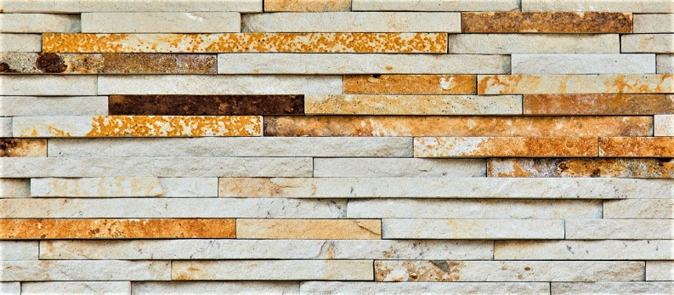 | LAPSA TAIATA  N-2 COSAUTI  H-2 (cm)  Lungime - libera  Grosime - 1.5-2.5 (cm)  Greutate - 27-32 kg/m2 | 220 lei/m2
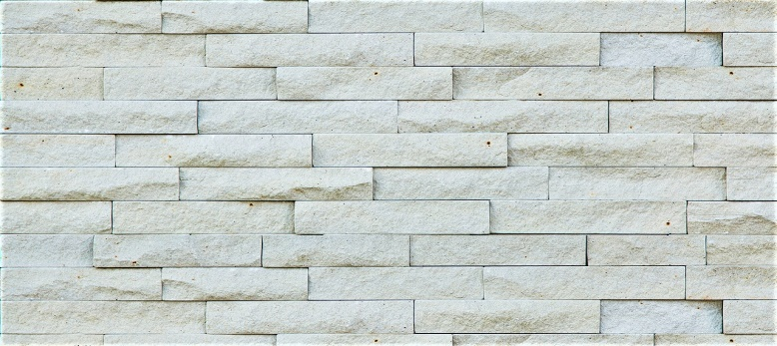 | LAPSA DESPICATA  N3 -COSAUTI  H-3 (cm)  Lungime - libera  Grosime -1.2- 1.8 (cm)  Greutate - 25-30 kg/m2 | 200 lei/m2
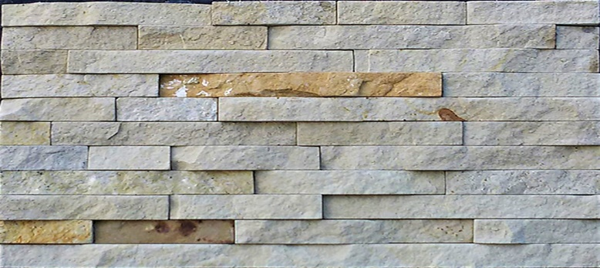 | LAPSA TAIATA  N-3 COSAUTI  H-3 (cm)  Lungime - libera  Grosime -1.5- 2.5 (cm)  Greutate - 30-35 kg/m2 | 215 lei/m2
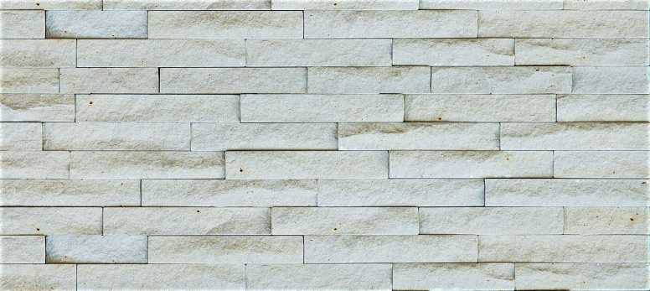 | LAPSA DESPICATA  N-4-COSAUTI  H-4 (cm)  Lungime - libera  Grosime -1.2- 2 (cm)  Greutate - 28-33 kg/m2 | 200 lei/m2
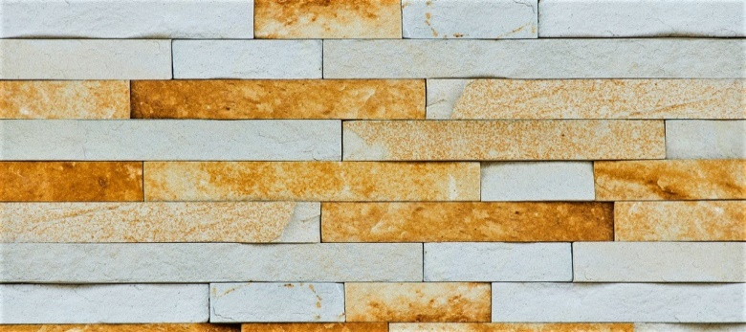 | LAPSA TAIATA  N-4 COSAUTI  H-4 (cm)  Lungime - libera  Grosime -1- 1.5 (cm)  Greutate - 32-37 kg/m2 | 210 lei/m2
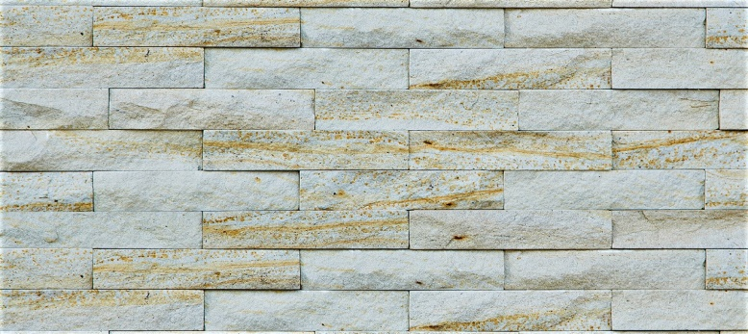 | LAPSA DESPICATA  N-5-COSAUTI  H-2 (cm)  Lungime - libera  Grosime -1- 1.8 (cm)  Greutate - 28-33 kg/m2 | 200 lei/m2
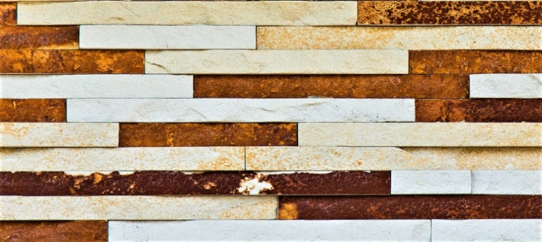 | LAPSA TAIATA  N-5 COSAUTI  H-1.5 (cm)  Lungime - libera  Grosime -1- 1.5 (cm)  Greutate - 35-40 kg/m2 | 200 lei/m2
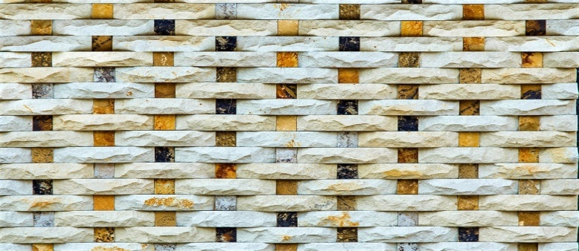 | TERACOTA-MOZAIC  (PLETEONCA)  **MARIMI-STANDART  4*20-4*4 (cm)  4*20-2*4 (cm)  Lungime -20 (cm)  Grosime -1.5- 2.5*3 (cm)  Greutate – 40-45 kg/m2  Deviere de masura +20 lei/m2 | 320 lei/m2  320 lei/m2  +20 lei/m2
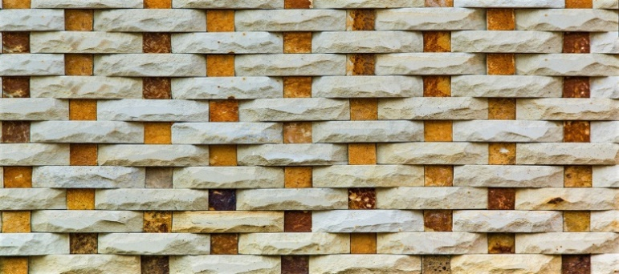 | TERACOTA-MOZAIC  (PLETEONCA)  **MARIMI-STANDART  5*20-5*5 (cm)  3*30 –fara cub  Lungime -20 (cm)  Grosime -1.5- 2.5*3 (cm)  Greutate – 40-45 kg/m2  Deviere de masura +20 lei/m2 | 280 lei/m2  300 lei/m2  +20 lei/m2
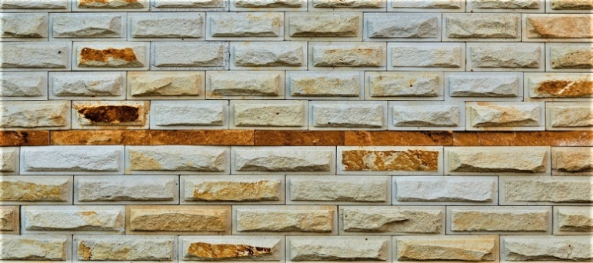 | TERACOTA-COSAUTI  ****rupta  **MARIMI- STANDART  7*15 (cm)  7*20 (cm)  Grosime -1.5- 2.5 (cm)  Greutate - 40-55 kg/m2  Deviere de masura +20 lei/m2 | 280 lei/m2  +20 lei/m2
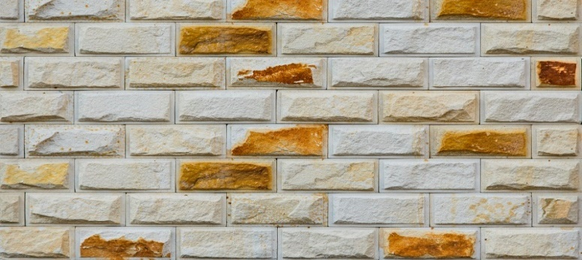 | TERACOTA-COSAUTI  ****rupta  *MARIME-STANDART  10*20-10*10 (cm)  Grosime -1.5- 2.5 (cm)  Greutate - 30-50 kg/m2  Deviere de masura +20 lei/m2 | 230 lei/m2  +20 lei/m2
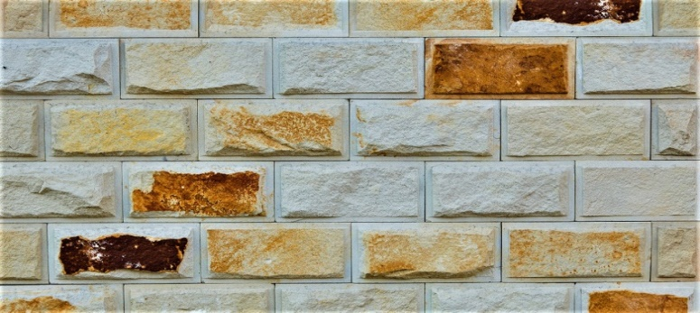 | TERACOTA-COSAUTI  ****rupta  *MARIME-STANDART  12*24-12*12 (cm)  Grosime -1.5- 2.5 cm  Greutate - 30-50 kg/m2  Deviere de masura +20 lei/m2 | 230 lei/m2  +20 lei/m2
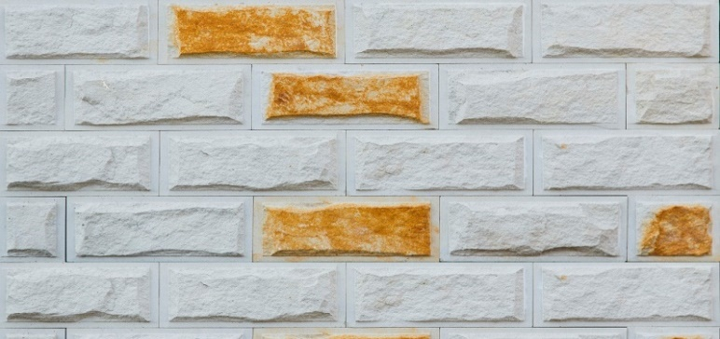 | TERACOTA-COSAUTI  ****rupta  *MARIME-STANDART  15*30-15*15 (cm)  15*20 (cm)  Grosime -1.5- 2.5 cm  Greutate - 30-50 kg/m2  Deviere de masura +20 lei/m2 | 230 lei/m2  +20 lei/m2
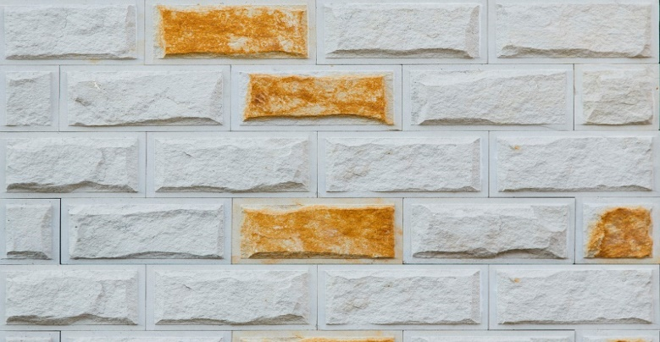 | TERACOTA-COSAUTI  ****rupta  20*40-20*20 (cm)  20*30 (cm)  Grosime -1.5- 3 (cm)  Greutate - 50-65 kg/m2  Deviere de masura +20 lei/m2 | 280 lei/m2  +20 lei/m2
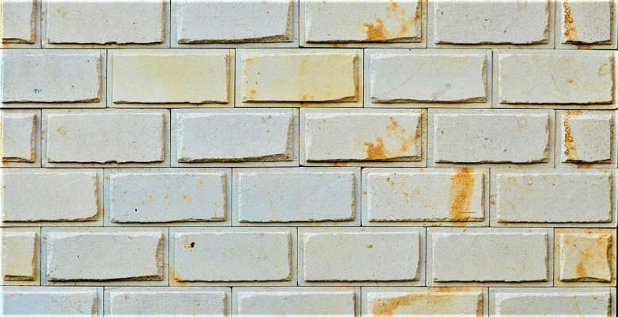 | TERACOTA-COSAUTI  ****șlefuită  15*30-15*15 (cm)  12*24-12*12 (cm)  10*20-10*10 (cm)  Grosime -2 (cm)  Greutate – 30-40 kg/m2  Deviere de masura +20 lei/m2 | 260 lei/m2  +20 lei/m2
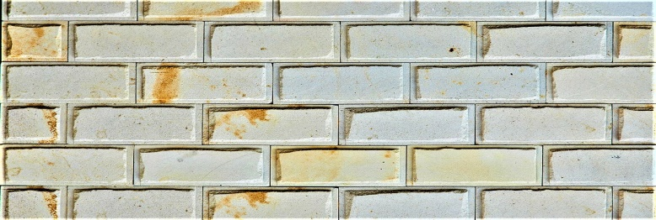 | TERACOTA-COSAUTI ****șlefuită  7*15 (cm)  7*20 (cm)  Grosime -2 (cm)  Greutate-30-40 kg/m2  Deviere de masura +20 lei/m2 | 260 lei/m2  +20 lei/m2
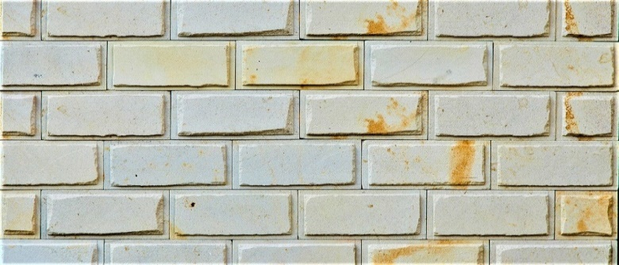 | TERACOTA-COSAUTI ****șlefuită  15*20 (cm)  20*30-20*15 (cm)  20*40-20*20 (cm)  Grosime -2 (cm)  Greutate-30-40 kg/m2  Deviere de masura +20 lei/m2 | 280 lei/m2  +20 lei/m2
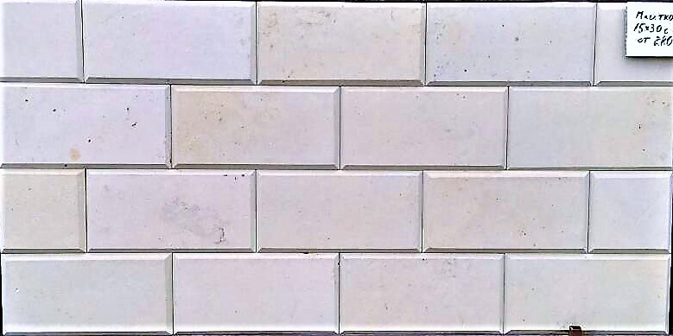 | TERACOTA-COSAUTI  șlefuita  10*20 / 12*24 / 15*30  Grosime -2 (cm)  Grosime -2,5 (cm)  Grosime -3 (cm)  Grosime -3,5 (cm)  Grosime -4 (cm)  Greutate – 30-50 kg/m2  Deviere de masura +20 lei/m2 | 270 lei/m2  300 lei/m2  320 lei/m2  350 lei/m2  400 lei/m2  +20 lei/m2
 | TERACOTA-COSAUTI  șlefuita  20*40 / 20*20 / 20*30  Grosime -2 (cm)  Grosime -2,5 (cm)  Grosime -3 (cm)  Grosime -3,5 (cm)  Grosime -4 (cm)  Greutate – 30-50 kg/m2  Deviere de masura +20 lei/m2 | 300 lei/m2  330 lei/m2  360 lei/m2  380 lei/m2  420 lei/m2  +20 lei/m2
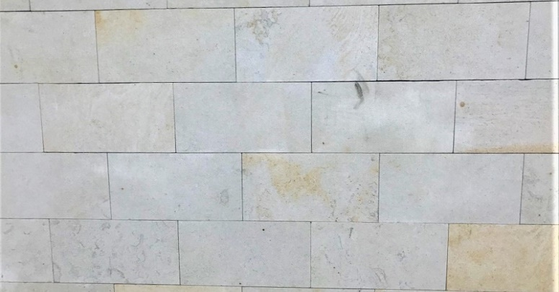 | TERACOTA-COSAUTI  șlefuita  10*20 / 12*24 / 15*30  Grosime -1,5 (cm)  Grosime -2 (cm)  Grosime -2,5 (cm)  Grosime -3 (cm)  Grosime -3,5 (cm)  Grosime -4 (cm)  Greutate – 30-50 kg/m2  Deviere de masura +20 lei/m2 | 210 lei/m2  230 lei/m2  250 lei/m2  270 lei/m2  290 lei/m2  320 lei/m2  +20 lei/m2
 | TERACOTA-COSAUTI  șlefuita  20*40 / 20*20 / 20*30  Grosime -1,5 (cm)  Grosime -2 (cm)  Grosime -2,5 (cm)  Grosime -3 (cm)  Grosime -3,5 (cm)  Grosime -4 (cm)  Greutate – 30-50 kg/m2  Deviere de masura +20 lei/m2 | 240 lei/m2  260 lei/m2  280 lei/m2  300 lei/m2  320 lei/m2  340 lei/m2  +20 lei/m2
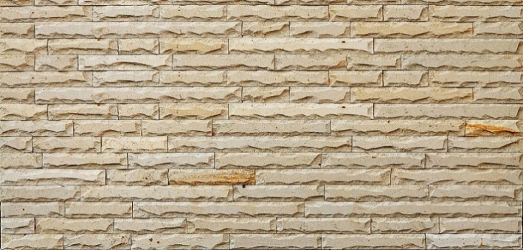 | COSAUTI SCOL  H-5(cm)--Grosime 1.2(cm)  H-7.5(cm) Grosime-1.5(cm)  H-10(cm)-Grosime -2(cm)  Lungime - libera  Greutate - 22-30kg/m2 | 250 lei/m2
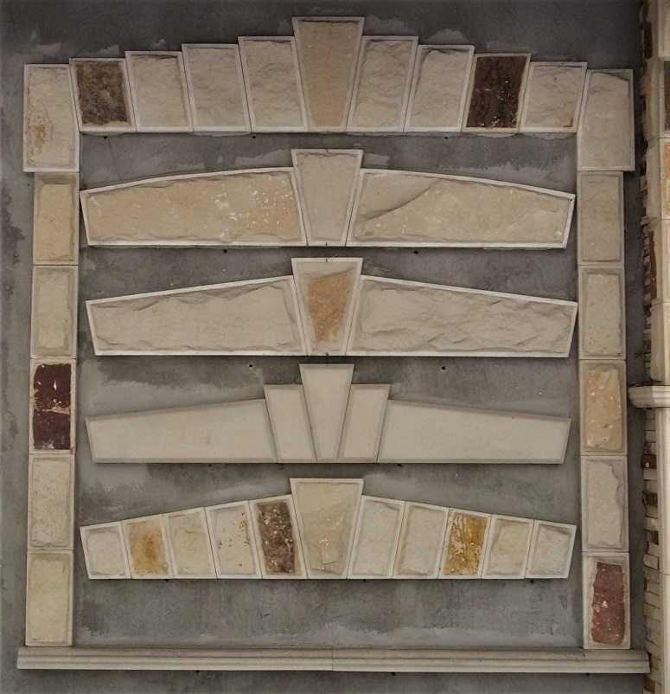 | COROANE LA  FERESTRE SI USI  Coroanele se pregateste  individual dupa masurile  laturei de sus a ferestrei sau a usii si se calculeaza la metru linear.  Partile laterale a ferestrei sau a usii se calculeaza la metru patrat | 350--450  lei/liniar
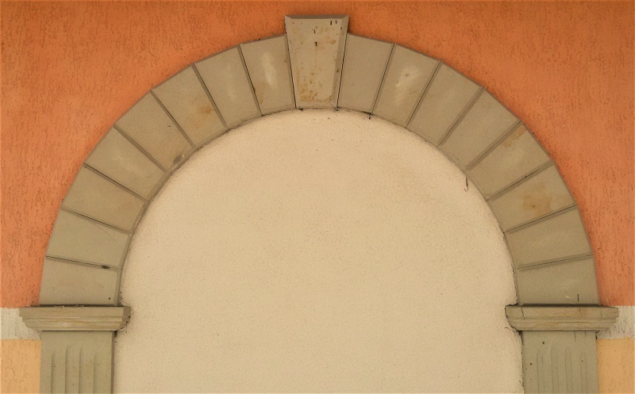 | COROANE  SEMIROTUNDE PENTRU  FERESTRE SI USI  Coroanele se pregateste  individual dupa masurile  laturei semirotundede a ferestrei sau a usii si se calculeaza la metru linear.  Pentru a taia raza semirotunda avem nevoie de sablon. | 450--550  lei/liniar
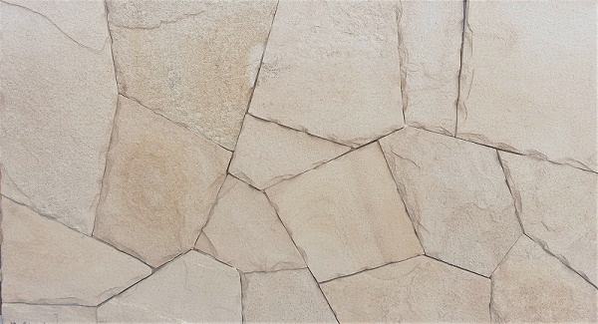 | COSAUTI LESPEDE  Grosime -3-5 (cm)  10-20 buc/m2  ***MĂSURI APROXIMATIVE | 1400lei/m3  100lei/m2
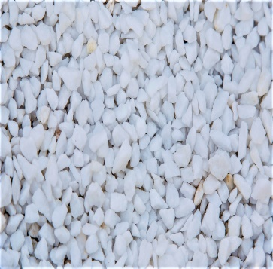 | GRECIA MRAMORA—ALBA  **SPARTA  Fractia ------4*6mm  Fractia ------5*10 mm  Fractia ------10*16 mm  Fractia ------16*32 mm  Fractia-------20*40 mm  Fractia ------30*60 mm  Fractia-------40*80 mm  Fractia-------80*130 mm  Fractia-------130*250 mm | 11lei/kg  10lei/kg/sac
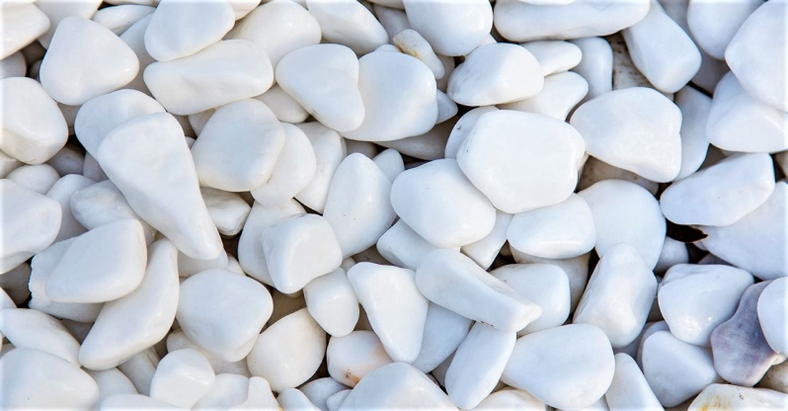 | GRECIA MRAMORA—ALBA  **ROTUNDA  Fractia ------4*6mm  Fractia ------5*10 mm  Fractia ------10*16 mm  Fractia ------16*32 mm  Fractia-------20*40 mm  Fractia ------30*60 mm  Fractia-------40*80 mm  Fractia-------80*130 mm  Fractia-------130*250 mm | 12lei/kg  11lei/kg/sac
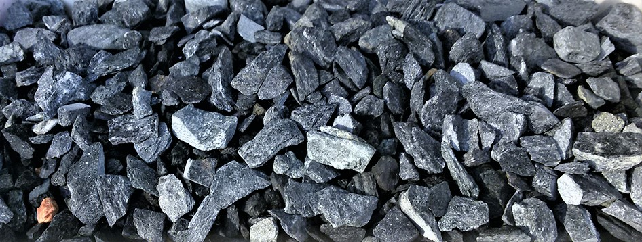 | GRECIA MRAMORA--VERDE  ** SPARTA  Fractia ------4*6mm  Fractia ------5*10 mm  Fractia ------10*16 mm  Fractia ------16*32 mm  Fractia-------20*40 mm  Fractia ------30*60 mm  Fractia-------40*80 mm  Fractia-------80*130 mm  Fractia-------130*250 mm | 11lei/kg  10lei/kg/sac
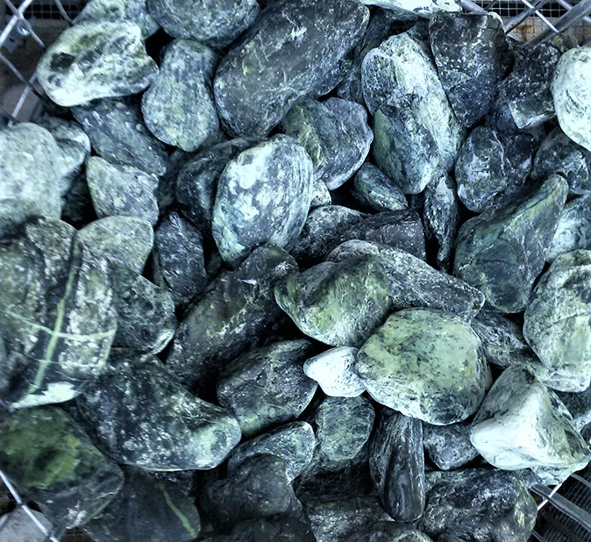 | GRECIA MRAMORA--VERDE  **ROTUNDA  Fractia ------4*6mm  Fractia ------5*10 mm  Fractia ------10*16 mm  Fractia ------16*32 mm  Fractia-------20*40 mm  Fractia ------30*60 mm  Fractia-------40*80 mm  Fractia-------80*130 mm  Fractia-------130*250 mm | 13lei/kg  12lei/kg/sac
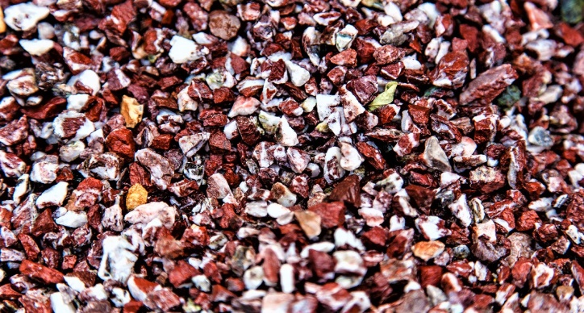 | GRECIA MRAMORA--ROYAL  **SPARTA  Fractia ------4*6mm  Fractia ------5*10 mm  Fractia ------10*16 mm  Fractia ------16*32 mm  Fractia-------20*40 mm  Fractia ------30*60 mm  Fractia-------40*80 mm  Fractia-------80*130 mm  Fractia-------130*250 mm | 11lei/kg  10lei/kg/sac
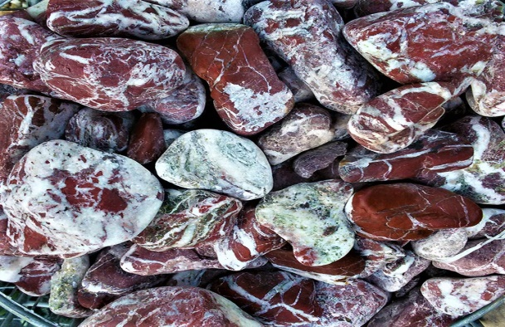 | GRECIA MRAMORA--ROYAL  **ROTUNDA  Fractia ------4*6mm  Fractia ------5*10 mm  Fractia ------10*16 mm  Fractia ------16*32 mm  Fractia-------20*40 mm  Fractia ------30*60 mm  Fractia-------40*80 mm  Fractia-------80*130 mm  Fractia-------130*250 mm | 14lei/kg  13lei/kg/sac
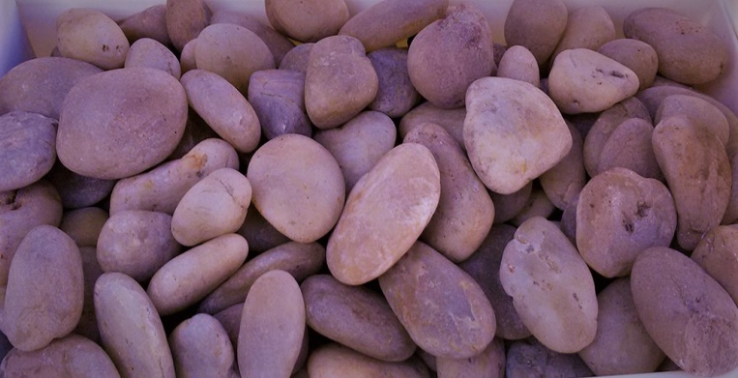 | MARMELADA  **ROTUNDA  Fractia-------20*40 mm | 24lei/kg
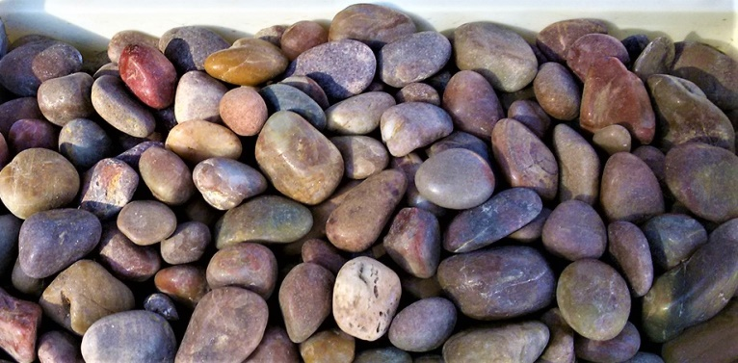 | CURCUBEU  **ROTUNDA  Fractia-------20*40 mm | 24lei/kg
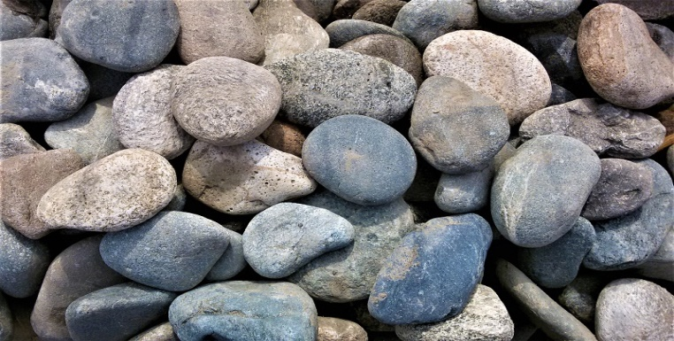 | PIATRA DE RIU  ADEGHEA  PENTRU BAIE SAUNA  Fractia 7-15 cm | 8lei/kg
 | PIATRA DE RIU  ADEGHEA  PENTRU BAIE SAUNA  DESING-OGRADA  Fractia 15-40 cm | 4lei/kg
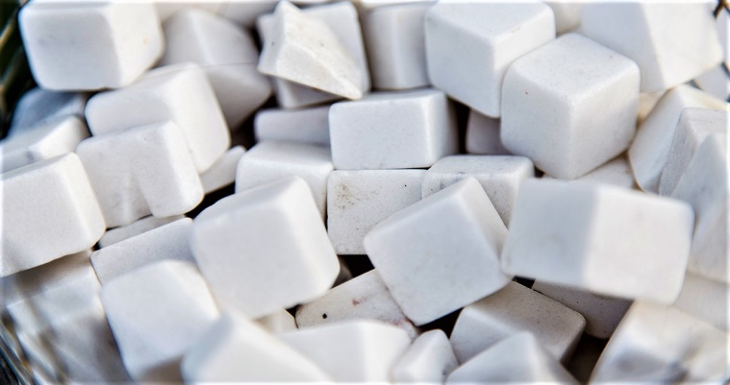 | GRECIA MRAMORA  ALBA-CUB  Fractia 25*25 mm | 24lei/kg
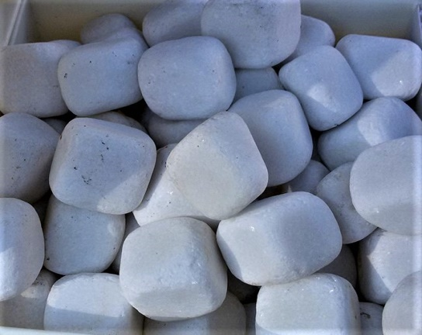 | GRECIA MRAMORA  ALBA-CUB ROTUGIT  Fractia 25*25 mm | 24lei/kg
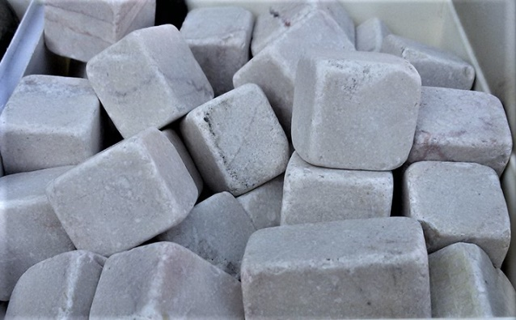 | GRECIA MRAMORA  CREMA-CUB  Fractia 25*25 mm | 24lei/kg
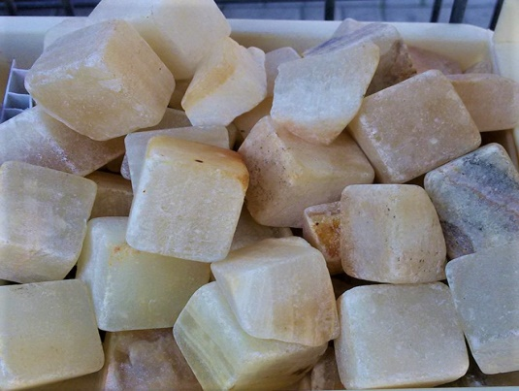 | MARMELADA-CUB  Fractia 25*25 mm | 24lei/kg
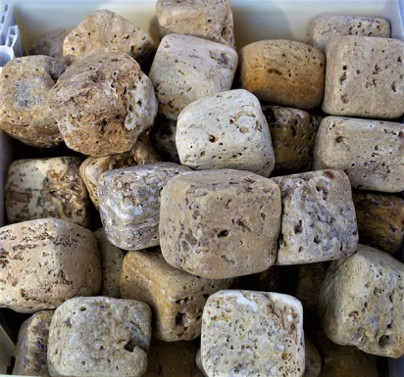 | TRAVERTIN -CUB  Fractia 25*25 mm | 24lei/kg
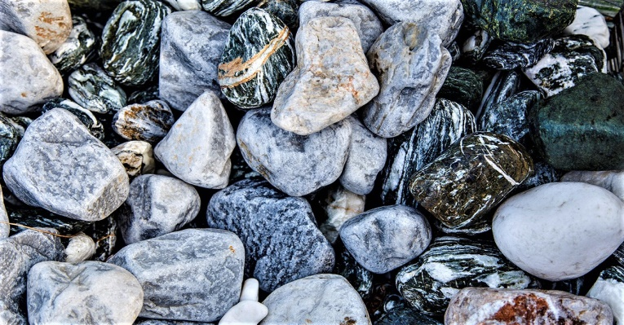 | PIATRA DECORATIVA  DJEANS  IN DIAMETRU 6-15 cm | 19lei/kg
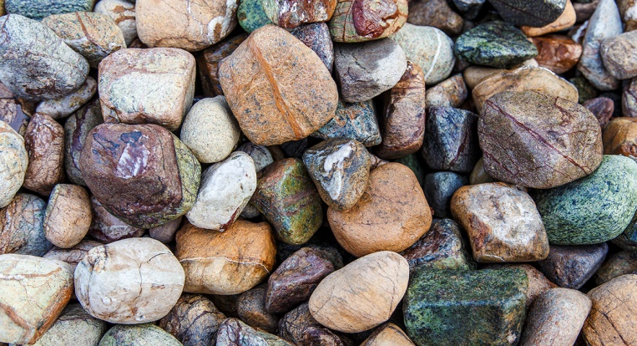 | PIATRA DECORATIVA DE RIU  INDIA  IN DIAMETRU 6-8 cm | 12lei/kg
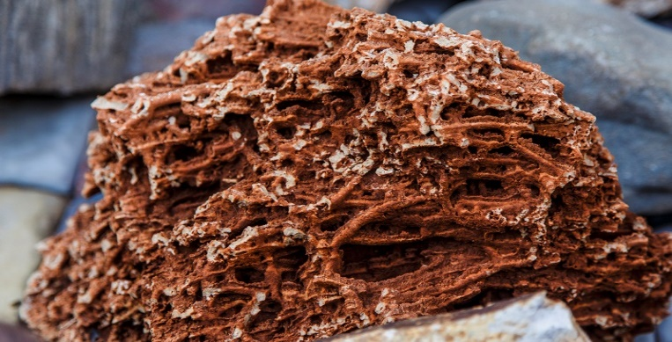 | CORAL  MASURI DIFERITE | 22lei/kg
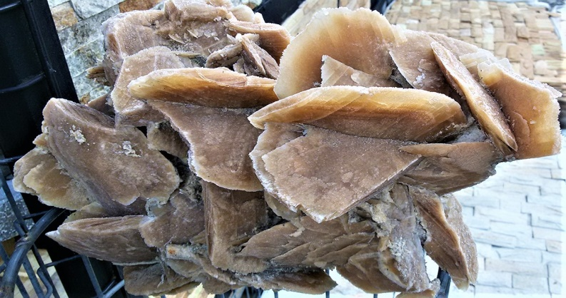 | TRANDAFIRUL PUSTIULUI  MASURI DIFERITE | 100lei/kg
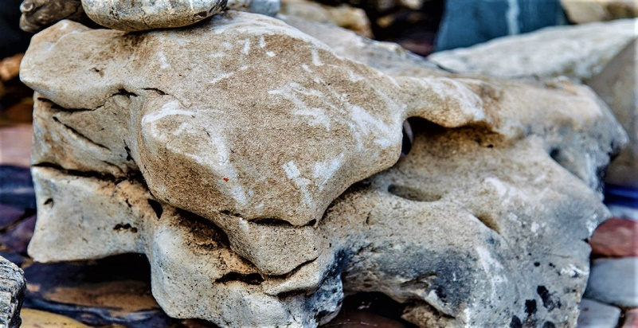 | TRAVERTIN  MASURI DIFERITE | 10lei/kg
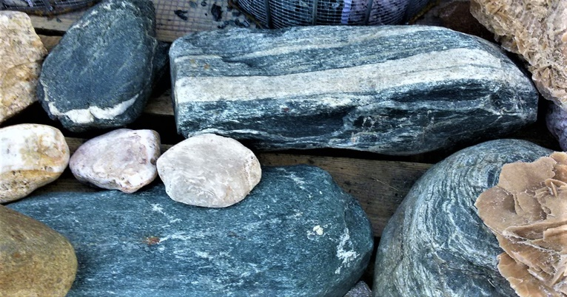 | BOLOVANI-DECORATIVI | 19lei/kg
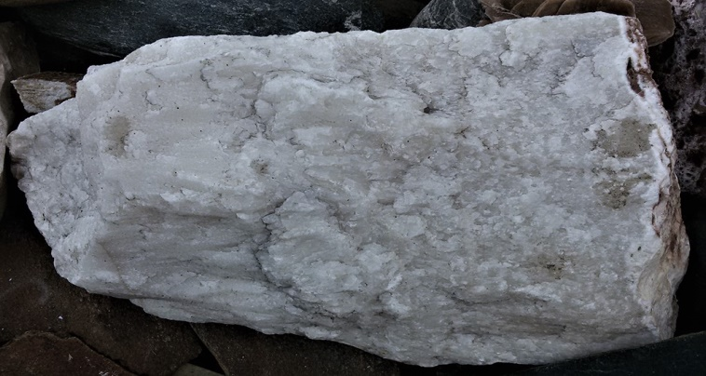 | STALACTIT  MASURI-DIVERSE | 20lei/kg

